**Lab 4:** Installation of ZoneAlarm and ProtonVPN and the hardening of Windows Defender Firewall

**Security Team:** Luis Ruiz, Marcos Vallejos, Ryan Rockett, Kari Hattabaugh

Table of Contents

Introduction (Kari) 2

Scope (Kari) 2

ProtonVPN 4

Information About Tool (Ryan) 4

Prerequisites (Ryan) 4

Instructions (Luis) 5

Installation 5

Configuration 14

Testing 17

Recommendations (Kari) 19

Alternatives (Marcos) 19

Windows Defender Firewall 20

Information About Tool (Ryan) 20

Prerequisites (Ryan) 20

Instructions (Luis) 21

Configuration 21

Testing 32

Recommendations (Kari) 34

Alternatives (Marcos) 34

ZoneAlarm 35

Information About Tool (Ryan) 35

Prerequisites (Ryan) 36

Instructions (Luis) 37

Installation 37

Configuration 41

Testing 53

Recommendations (Kari) 58

Alternatives (Marcos) 58

Conclusion (Kari) 59

References 60

# Introduction (Kari)

Ashburn’s Frog Emporium has tasked our security team with developing and implementing an integrated defense in depth strategy regarding their information security. We implemented two tools, ZoneAlarm and ProtonVPN, and hardened Windows Defender Firewall which is a security tool built into the newer versions of windows. These three tools work in conjunction to control, filter, and monitor the traffic to the devices on our network. Using these tools together ensures that if any of them are bypassed by or fail to prevent malicious traffic the other tools are likely to prevent it from doing damage.

# Scope (Kari)

Ashburn’s Frog Emporium is a small scale business, which offers online and in person sales. With the growing need for Information Security and their expanding customer base, Ashburn’s Frog Emporium is looking to improve their security. Through the next 90 days, our team will identify, install, and configure a variety of tools to provide a cost effective layered defense to Ashburn’s Frog Emporium. The network consists of workstations, point of sale devices, and servers. The operating systems used are Windows 10 and Windows Server 2016.

Previously we have installed Wireshark, which captures network traffic and allows an in depth examination of the packet headers. This provides us with insight into the TCP flag, IP addresses, protocols, and ports used. This information can show indicators of an attack. Next, we installed Prometheus, which is used to monitor network traffic and allows for configuration for alarm triggering parameters to be set. This offers network monitoring capabilities to Ashburn’s Frog Emporium’s network. We also installed Snort, which is a network monitoring tool used to identify and alert the user to attack signatures. Veracrypt, which is a tool that creates a container on a local device and encrypts the files, was also installed to limit access to sensitive data stored locally on a machine.

We plan to configure the built-in Window Defender Firewalls, then install ZoneAlarm and ProtonVPN. These are focused towards securing traffic into and out of the network as well as allowing for a secure channel through the public network for secure communication. Windows Defender Firewall is a built-in security tool that comes pre-installed in the later Windows OS versions. The hardening process of this tool will produce a log file for traffic onto our devices as well as limit malicious traffic. ZoneAlarm will act as our primary firewall, as well as an antivirus software. ZoneAlarm is designed to notify the user when there is malware detected or if one of the firewall rules are violated. ProtonVPN allows for a secure channel of communication out of Ashburn’s Frog Emporium. These three tools will allow for fault tolerant control over the traffic into and out of the network.

|  |  |  |
| --- | --- | --- |
| **Layer** | **Description** | **Tools Applied** |
| Physical Security | Measures taken to protect a computer or other network device from theft, fire, or environmental disaster. |  |
| Authentication and Password Security | Password policies, identity verification, etc. |  |
| Operating System Security | Maintaining and managing OS patches |  |
| Antivirus Protection | Protection the network and connected devices from malware. | ZoneAlarm |
| Packet Filtering | Blocking or allowing the transmission of packets based on configured criteria. | Windows Defender Firewall, ZoneAlarm |
| Firewalls | The tools installed and configured to manage traffic on a network, including firewall policies. | Windows Defender Firewall, ZoneAlarm |
| Demilitarized Zone (DMZ) | The area on the exterior of the network, which focuses on accessibility and the network’s perimeter security. |  |
| Intrusion Detection and Prevention Systems (IDPS) | Technology used to detect and in some cases produce an automated response to signatures, or patterns on suspicious network activity. | Prometheus, Snort |
| Virtual Private Network (VPN) | Technology that allows for secure communication using public internet connection. | ProtonVPN |
| Network Auditing and Log Files | Recording and organizing network activity and performance to allow for analytics. | Wireshark, Prometheus, Windows Defender Firewall |
| Routing and Access Control Methods | Tools that control or limit movement into and throughout the network. | Veracrypt, Windows Defender Firewall, ZoneAlarm |

# ProtonVPN

## Information About Tool (Ryan)

ProtonVPN is a virtual private network that is open source. ProtonVPN uses AES-256 encryption for traffic and the key exchange is performed with 4096-bit RSA. HMAC and SHA384 are also used for message authentication. ProtonVPN only uses certain VPN protocols that are known to be secure. These would be OpenVPN, IKEv2, and WireGuard.

One of the features that set ProtonVPN apart from the competition is the Secure Core feature. The Secure Core Feature is able to assist in defending against network-based attacks. Secure Core works primarily by doing two things, sending the traffic through several servers and by using full-disk encryption. The full-disk encryption secures the certificates on any of the exit servers, ensuring that in the unlikely event the physical server was taken, the encryption keys would still not be obtainable.

There are other features that are beneficial, one of these being the fact that ProtonVPN comes with Tor browsing support. This allows a company to reach the dark web to do research. ProtonVPN also helps protect against DNS queries, this is achieved by routing the DNS queries through several encrypted servers.

## Prerequisites (Ryan)

* The following platforms are supported by ProtonVPN
  + Android smartphones and tablets
    - Android version 6.0 or greater
  + iOS smartphones and tablets
    - iOS version 12.1 or greater
  + Windows 7, 8, 10
    - .NET framework is required. .Net is installed upon installation of ProtonVPN if .NET is not already installed.
  + macOS
    - If Mac is running macOS 10.14 or earlier, use version 1.9.3 of ProtonVPN
  + Linux distros
    - Debian 10
    - Ubuntu 20.04 (LTS)
    - Mint 20
    - MX Linux 19
    - Kali Linux
    - Elementary OS 6.0+
    - Fedora 33+
    - Achlinux / Manjaro
* There are four payment tiers that are associated with ProtonVPN. These tiers are Free, Basic, Plus, and Visionary. The cost for each if done on a two year payment cycle follow:
  + Free: $0.00 every 2 years.
  + Basic: $79.00 every 2 years.
  + Plus: $119.76 for the first two years, however this price is likely to change. During the research of this tool, ProtonVPN is running a special offer on the Plus tier.
  + Visionary: $479.00 every 2 years.

## Instructions (Luis)

### Installation

1. We will use ProtonVPN to protect our data in transit and secure communication channels within Ashburn’s Frog Emporium. While ProtonVPN can protect data in transit, it cannot protect data at rest however, this was covered with Veracrypt (Lab 3) and we will be using these two tools together to protect our data. To download ProtonVPN we will navigate to protonvpn.com/download and click “Download ProtonVPN” with the windows icon. The version we are installing is ProtonVPN_win_v1.24.1 which will work with Windows 10.

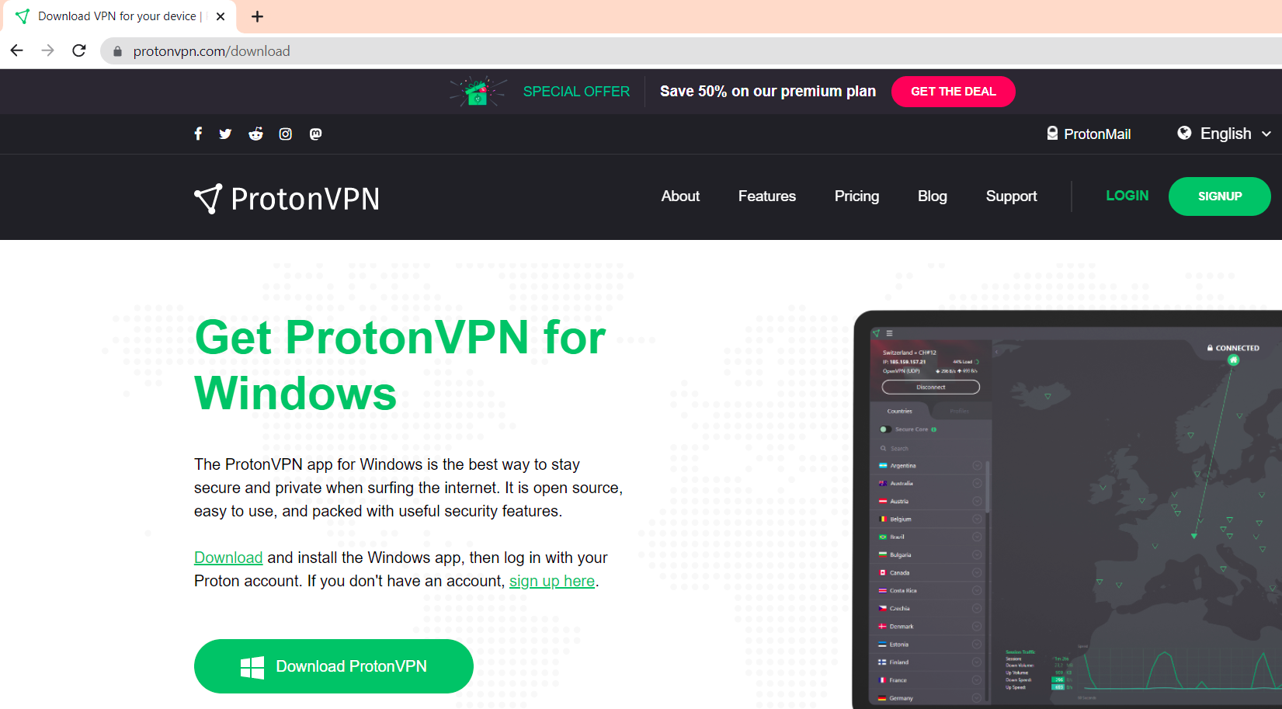

1. The downloaded file should be ProtonVPN_win_v1.24.1. Once verified, click on the file to launch the installation. 
2. Select “English” as the language and then click Next.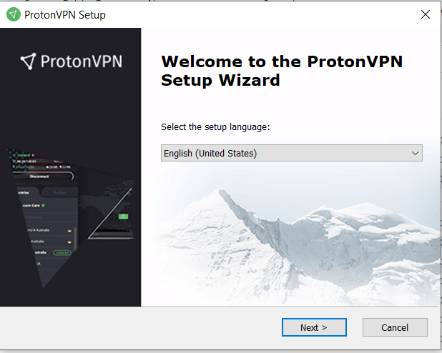
3. Click Next to continue the setup.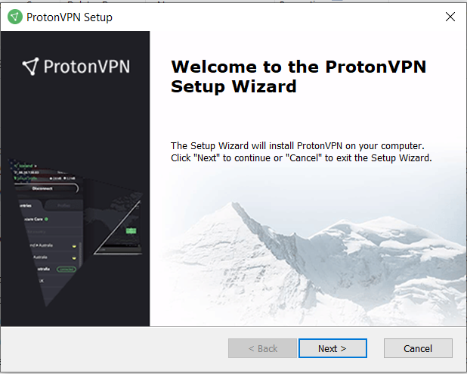
4. We will be installing the ProtonVPN in our program files. Browse to them and then click Next.

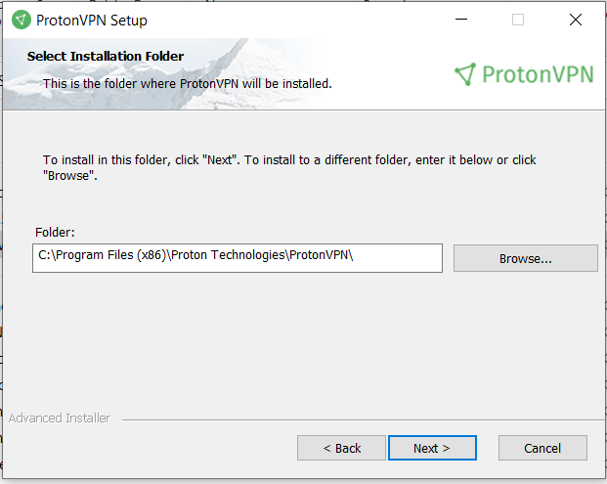

1. Click Install. 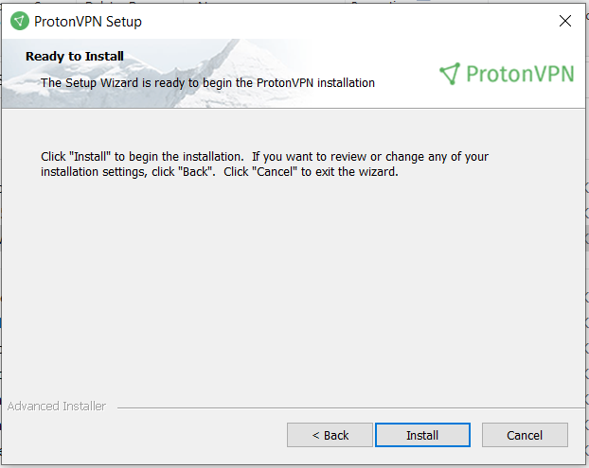
2. Once the installation is complete we will click finish.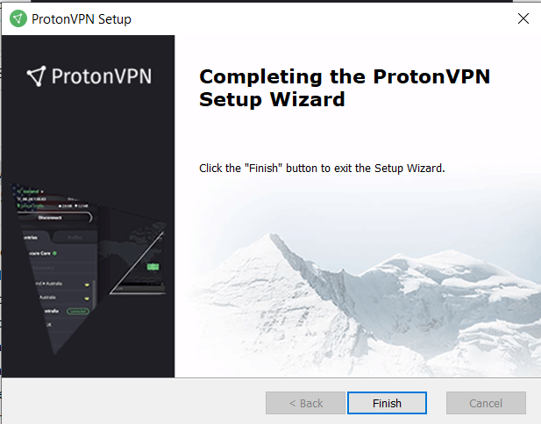
3. Now we will be prompted to create an account. On the lower left hand corner click “Create Account”

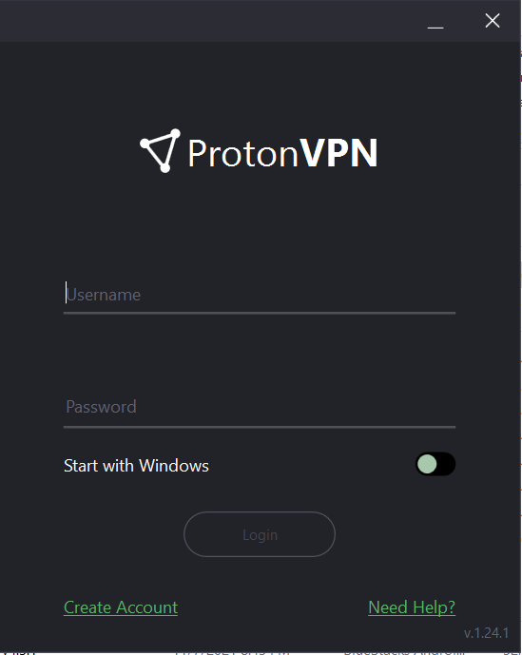

1. There are multiple payment options and plans available with each tier increasing our perks such as more tools, faster speeds, more location options. This is a great feature because it promotes scalability so as our business grows we can upgrade the tier to meet our business needs. For now, we only need the Free plan. Click “Get Free”

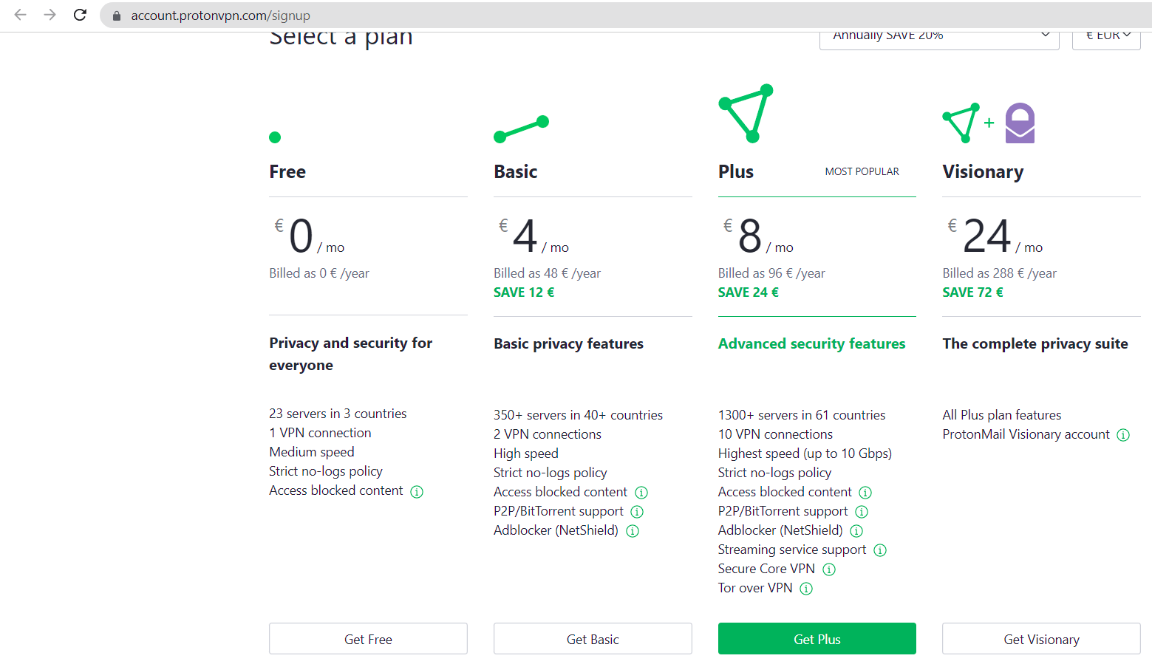

1. Choose the Username, password and email to create the account. The email address will be Ashburn’s Frog Emporium’s business email address and the Username and password should be business friendly.

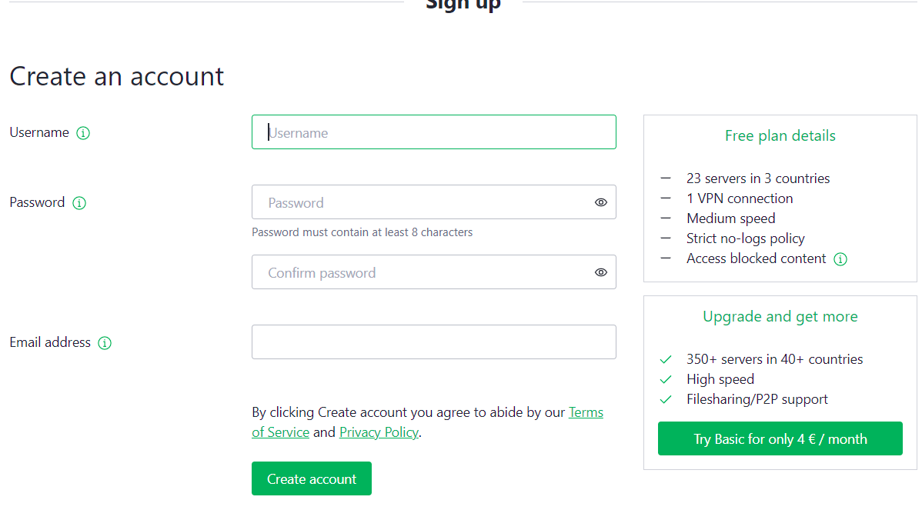

1. Enter Ashburn’s Frog Emporium’s business email address to receive the verification code.

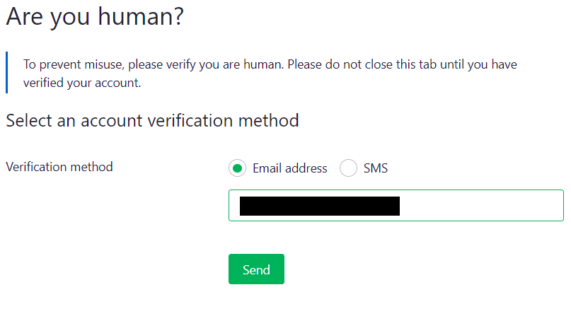

1. Make sure the verification code was sent to the correct email address. It might take a while to arrive, once it has arrived enter the code.

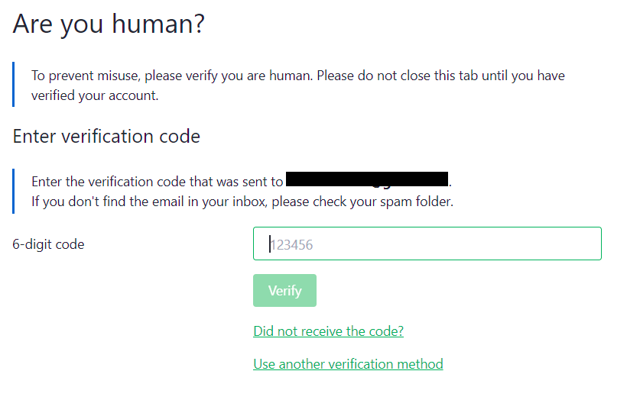

1. Open ProtonVPN back up and enter the login information then Login.

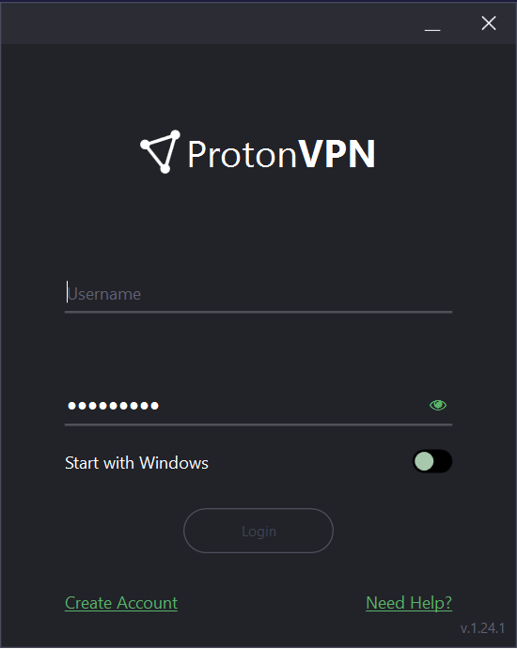

1. You will receive a Welcome Screen, click skip.

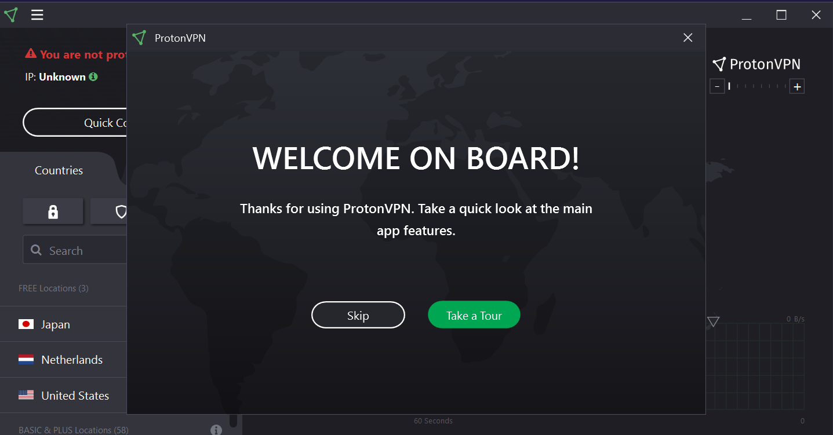

1. On the top left corner you will see a warning that says you are not connected to the VPN and the IP address you are using to connect to the internet.

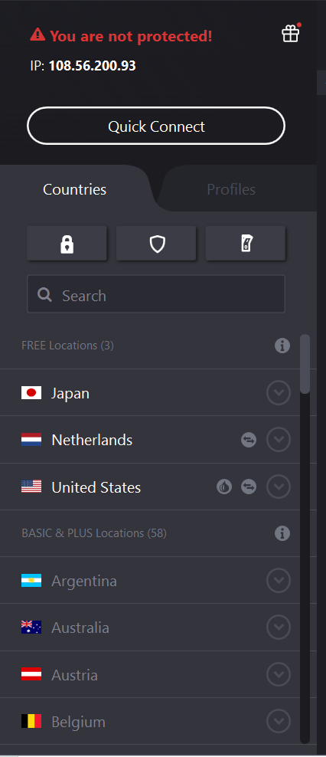

1. Click “Quick Connect” and you will notice that the IP address changed.

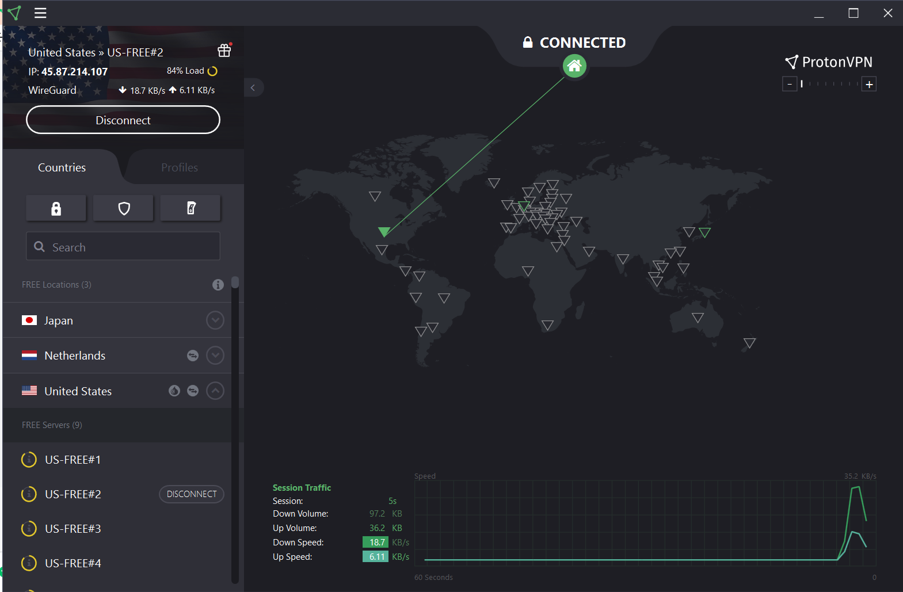

1. On the Left Panel of the GUI you will see that it has the connection information, IP address being used, upload and download speeds. A button to quickly disconnect. The countries tab will have three options, the only one that is available to free users is the third. The third button is the kill switch, more information on that later. Then we have the Free locations we can connect to, and the free servers. We also have a Profile tab, more information on that later.

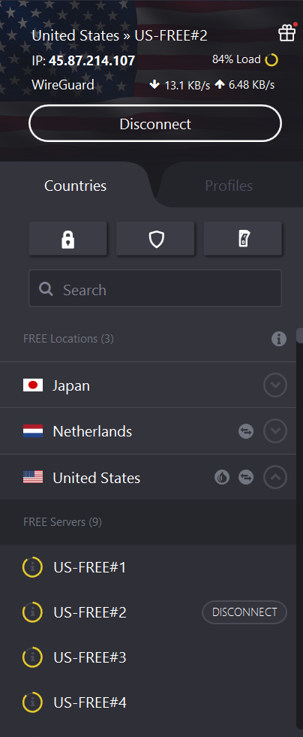

1. On the bottom panel we will have a graph showing the session traffic and speed. This is useful to refer to if you are noticing slower speeds, we can then switch to a second profile to get better speeds if needed.

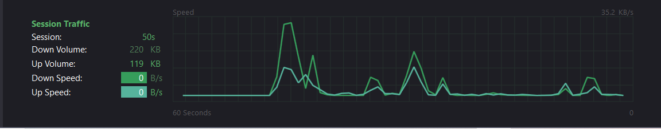

### Configuration

1. To begin our configurations we will first go to the left panel and click the switch button, this is the kill switch for our VPN. This means that if the VPN connection drops our internet connection will also drop until the VPN connection is restored. This will prevent us from defaulting to our IP addressing if the VPN is not active and will protect our privacy from data leaks.

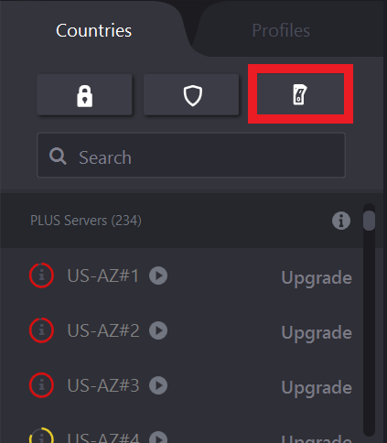

1. If the kill switch is on, it will turn green.

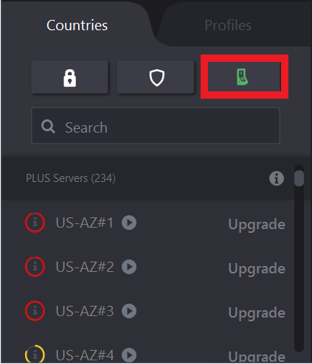

1. Click on the Profiles tab. We will now create custom profiles to quickly switch between servers in case our current server gets compromised.

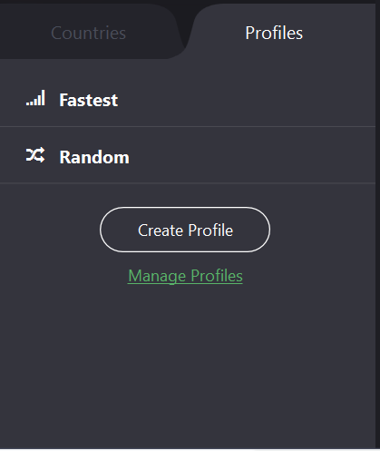

1. The Free edition only comes with the standard VPN connection, other versions have Peer-to-Peer, secure core, and a Tor connection. We will set the name for the first profile as “Quick Connect”, using a quick connect protocol, and to the first Free US server.

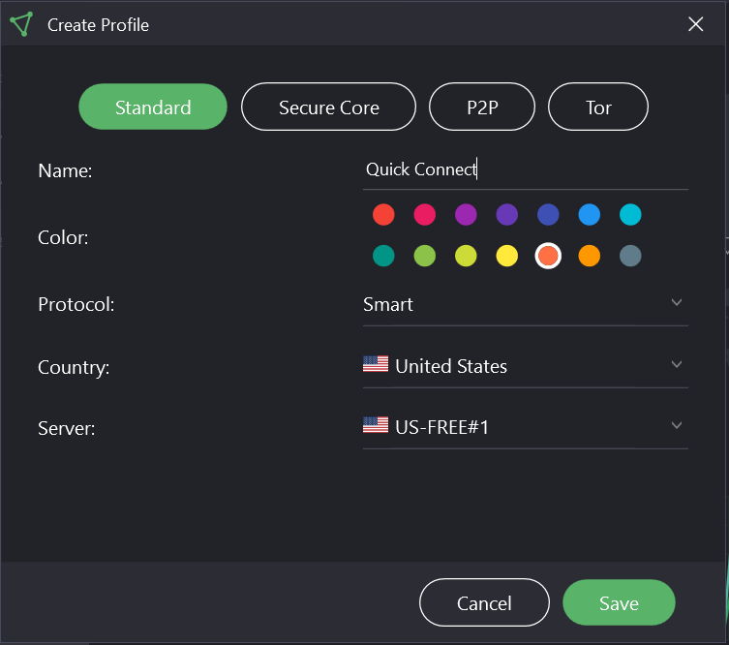

1. The Second Profile will be named “Quick Connect 2” and will be connected to the third server using the same configurations from the first server. We are not using other country’s servers so that we can maintain higher speeds. If our first server becomes compromised, we can quickly switch to the second profile onto the third server and still maintain decent speeds that will not impede our business objectives.

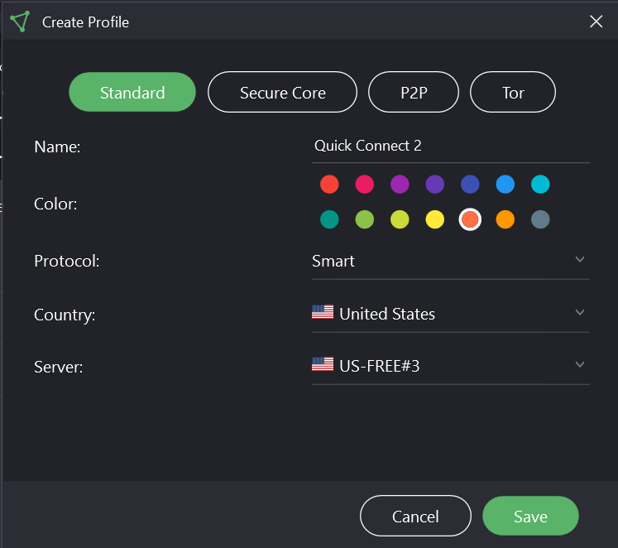

1. You will now see two profiles “Quick Connect” and “Quick Connect 2”.

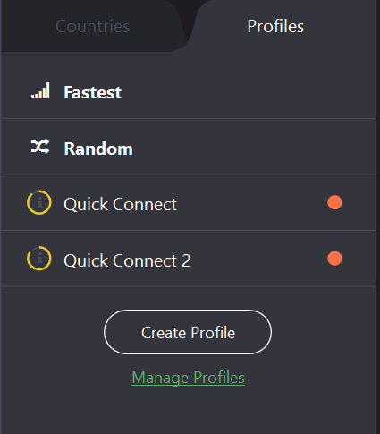

1. Connect to Quick Connect 1 so that we can try testing out the profiles by switching to Quick Connect 3. You will see that we are on the first free server, just as we configured it.

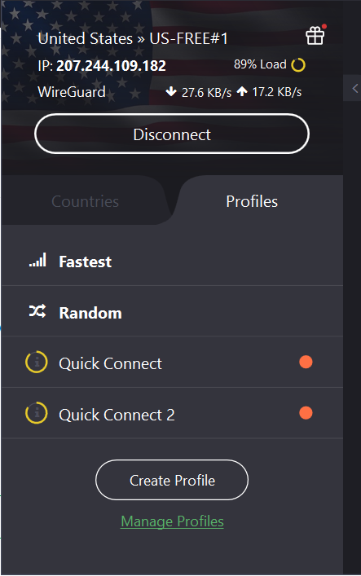

### Testing

1. We will now “lose” connection. You will see how our network defaulted to our own IP thanks to the kill switch, our internet connection will also go down so we don’t leak our IP as we are doing transactions. While this is not ideal, it is better than leaking our business IP to a third party and then having it used for a DDoS attack or similar.

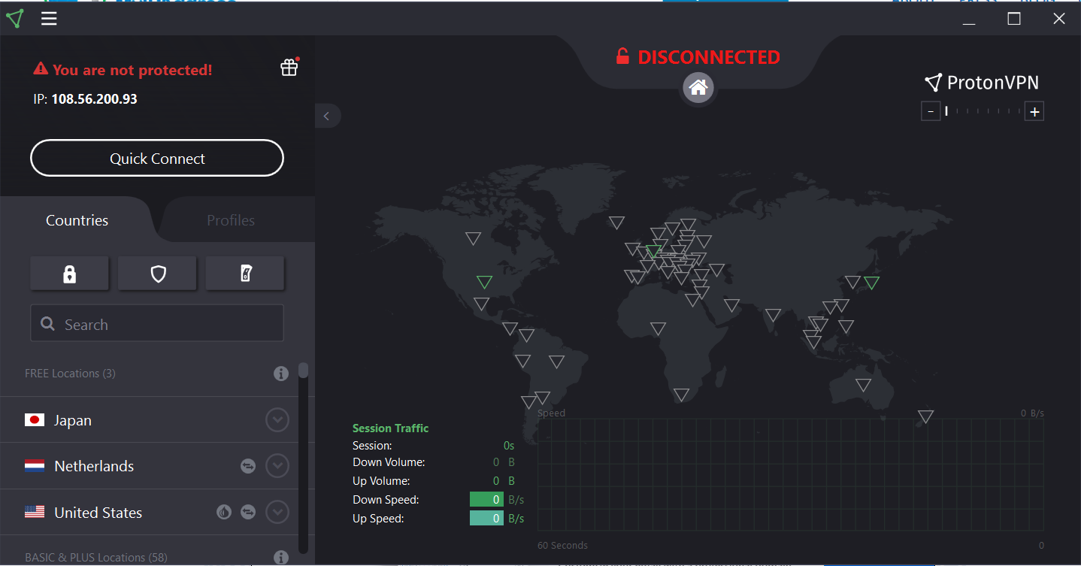

1. If we check our IP an attacker will see our location and service provider. We do not want this information exposed.

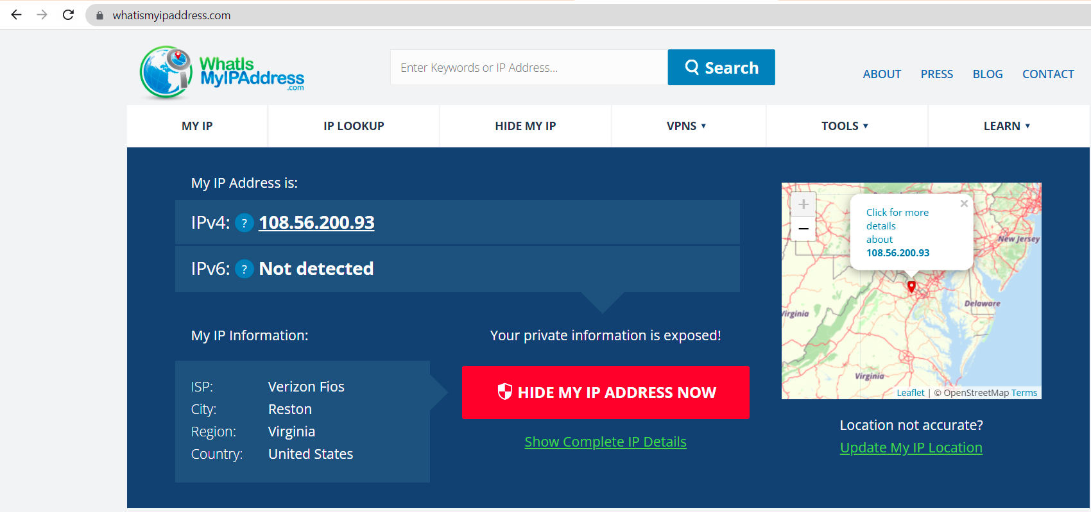

1. Since “Quick Connect” was compromised and the killswitch was activated to prevent data leakage we need to be able to quickly connect to a server we know is secure. Thankfully, we have a second profile “Quick Connect 2” that we can connect to and should also be secure.

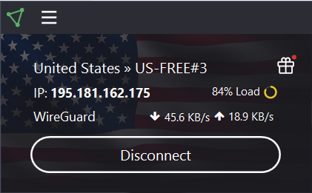

1. Let’s check Server 3’s connection and we will see that it is pinging to Florida. Our private information is secure and we can now continue our business operations as normal.

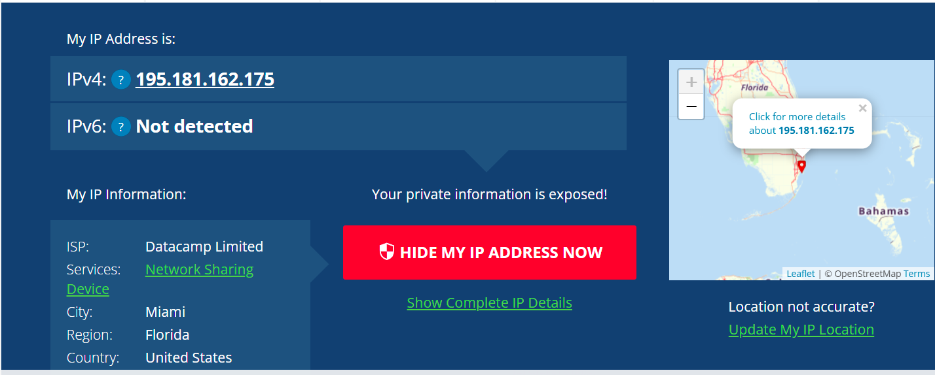

## Recommendations (Kari)

ProtonVPN is used to allow for secure communication over an unsecured network. This will maintain confidentiality to the sensitive data that Ashburn’s Frog Emporium handles. Our security team recommends that users review and keep the vendor support information close. The following URL has vendor provided configuring and troubleshooting information. <https://protonvpn.com/support/>

## Alternatives (Marcos)

An alternative to ProtonVPN would be NordVPN service. This software is a cross-platform virtual private network service that offers complete protection to one’s internet connection and privacy online. NordVPN has all the basic features that ProtonVPN has, including built-in leak protection and kill switches on all their VPN applications. NordVPN has integrated the Wireguard protocol into their network in the form of the NordLynx VPN protocol. This is a privacy-first implementation of Wireguard that uses a Double NAT system to secure user IP addresses. For encryption, NordVPN uses AES-256-GCM with a 4096-bit DH key or ChaCha20 ciphers. This VPN software provides many specialty servers for various use cases. It has P2P servers that are optimized for torrenting large files. NordVPN provides obfuscated servers that conceal VPN traffic as regular HTTPS encryption. Additionally, it has double-VPN servers that encrypt traffic over two different locations, similar to ProtonVPN’s Secure Core servers. NordVPN also contains Tor-over-VPN servers that add an additional layer of encryption via the Tor network. ProtonVPN also offers Tor-over-VPN servers, however, these servers are restricted to only the most expensive subscriptions. Lastly NordVPN has the security feature, CyberSec, which blocks ads, trackers, malware, and phishing domains. Unlike browser-based ad-blockers, NordVPN’s CyberSec feature will block ads and trackers on your entire operating system through the VPN.

The platform is compatible with all major operating systems, such as Windows, macOS, Android, and iOS devices. It has access to over 5,100 servers worldwide and can connect 6 devices simultaneously. There are 3 subscription plans, 1-month plan starting at $11.95 billed every month. There is a 1-year plan priced at $59.00 for the first year, then augmenting to $143.40 yearly. Finally, there is the 2-year plan which is priced at $89.00 for the first two years, then $286.80 every two years. The more VPNs we add to the subscription, the more Ashburn’s Frog Emporium would have to pay. In this case, we will continue to use the ProtonVPN software we have implemented. The Ashburn’s Frog Emporium would benefit from NordVPN’s impressive security features that provide maximum protection to our data assets. We would recommend implementing this VPN service to further strengthen our network and protect our data from malicious threats.

# Windows Defender Firewall

## Information About Tool (Ryan)

Windows Defender Firewall is a packet filtering tool that supports Internet Protocol security. Windows Defender Firewall gives host based and two way network traffic filtering for Windows devices on the network. Through the use of rules, network administrators are able to better filter out traffic that they do not want on their network from ever entering the network. The two way network traffic filtering gives it the ability to not only watch the traffic that is flowing into the network, but also anything that is going out in the case of an insider threat.

In addition to running on Windows operating systems, Windows Defender is able to run on mobile devices and other desktop solutions as an endpoint monitoring solution. This is due to how versatile the firewall is and how simple it is to use. The tool becomes more powerful when used in conjunction with Microsoft Management Console, as this becomes a central control center to configure and monitor the firewalls on networks.

## Prerequisites (Ryan)

* Windows Defender Firewall requires the following operating systems
  + Windows Vista
  + Windows 7
  + Windows 8
  + Windows 10
  + Windows 11
  + Windows Server 2008
  + Windows Server 2008 R2
  + Windows Server 2012
  + Windows Server 16 or above
  + Android 6.0 or above
  + iOS 12.0 and above
  + Linux distros
    - Red Hat Enterprise Linux 6.7 or higher
    - Red Hat Enterprise Linux 7.2 or higher
    - CentOS 6.7 or higher
    - CentOS 7.2 or higher
    - Ubuntu 16.04 LTS or higher LTS
    - Debian 9 or higher
    - SUSE Linux Enterprise Server 12 or higher
    - Oracle Linux 7.2 or higher
    - Amazon Linux 2
    - Fedora 33 or higher
  + The three most recent macOS are supported

## Instructions (Luis)

### Configuration

1. Windows Defender Firewall is a host based firewall that already comes preinstalled on Windows OS. As we are using Windows 10, we can access this by simply searching for “Windows Defender Firewall” in the search option. We will configure new inbound and outbound rules to allow network traffic through the firewall to Prometheus (Lab2) and ProtonVPN (Recently installed) so that they are not potentially blocked by the firewall policies. We will also allow logging for Windows Defender Firewall.

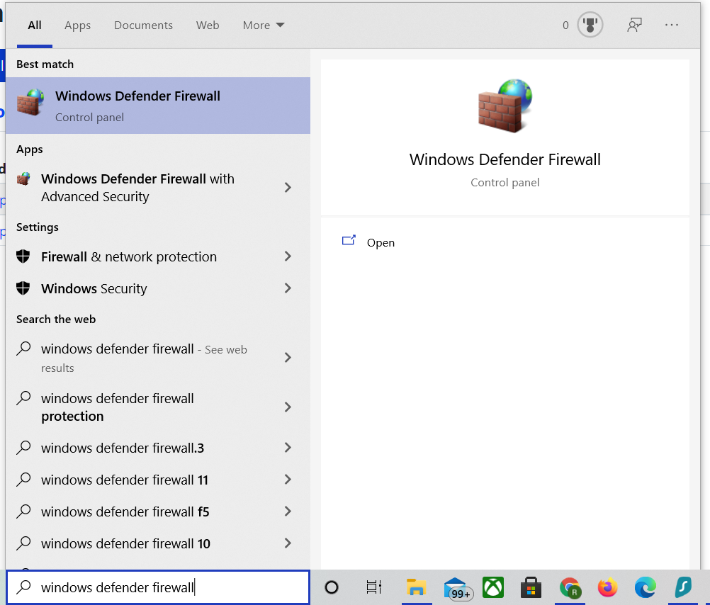

1. Once we select Windows Defender Firewall we will come across it’s home screen. Windows Defender Firewall is already configured to maximize security so, we will not be changing most default settings. In fact, needlessly changing the default settings could compromise security. Select “Advanced Settings”

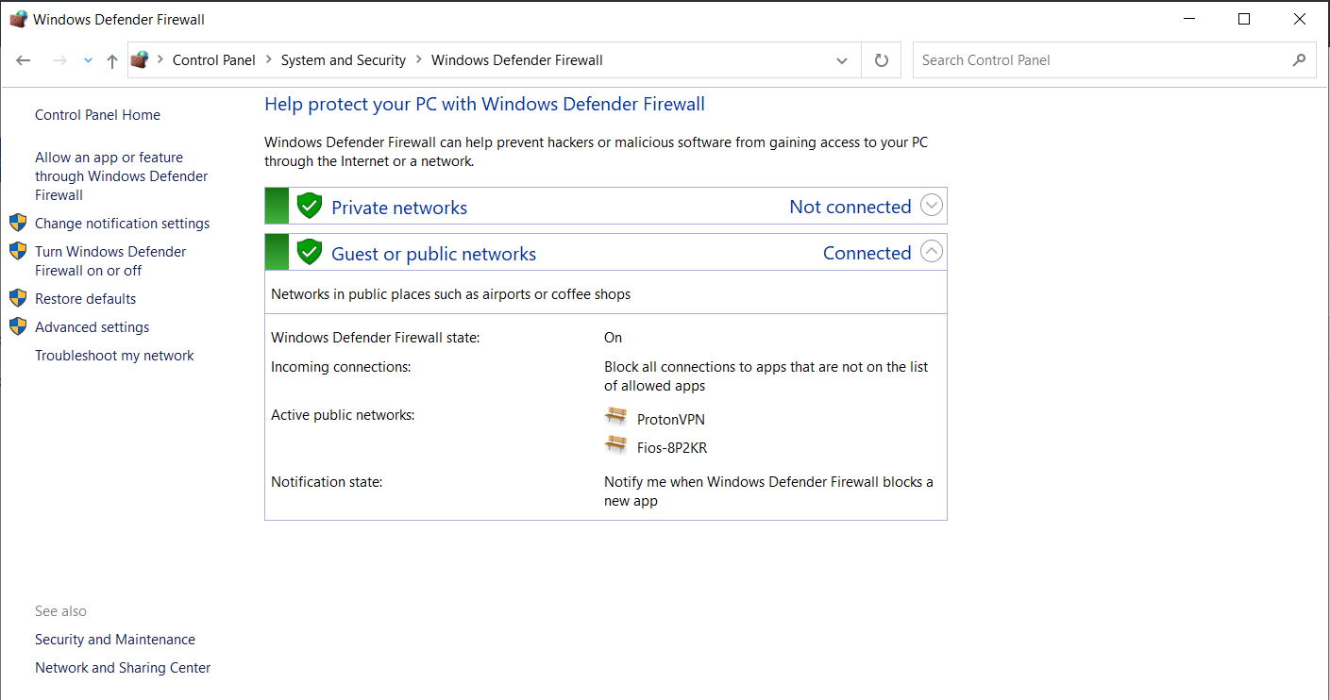

1. In the “Windows Defender Firewall with Advanced Security” Screen we will have a left panel to configure rules and monitoring and on the right panel we will have policy imports/exports and properties. Select “Inbound Rules”

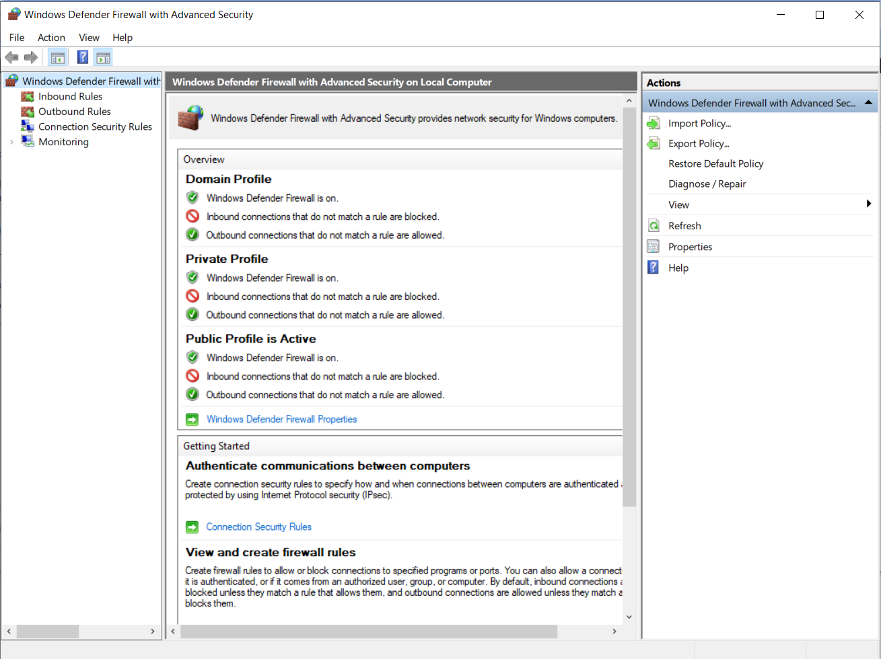

1. We will now see all the Inbound Rules currently applied, those with a green check are active and those without any green check are disabled. Select “New Rule” on the right panel. 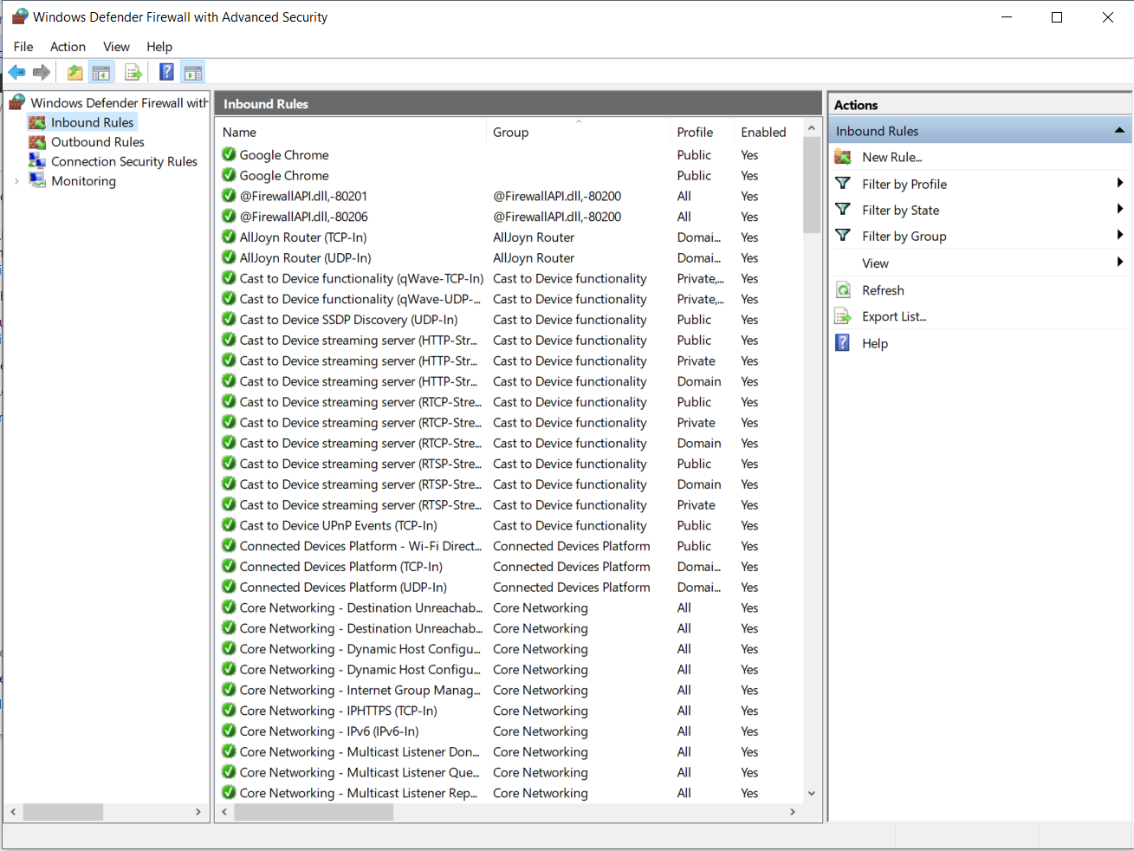
2. We will begin by creating a new Inbound Rule for Prometheus. Leave it selected on the Program option and click Next.

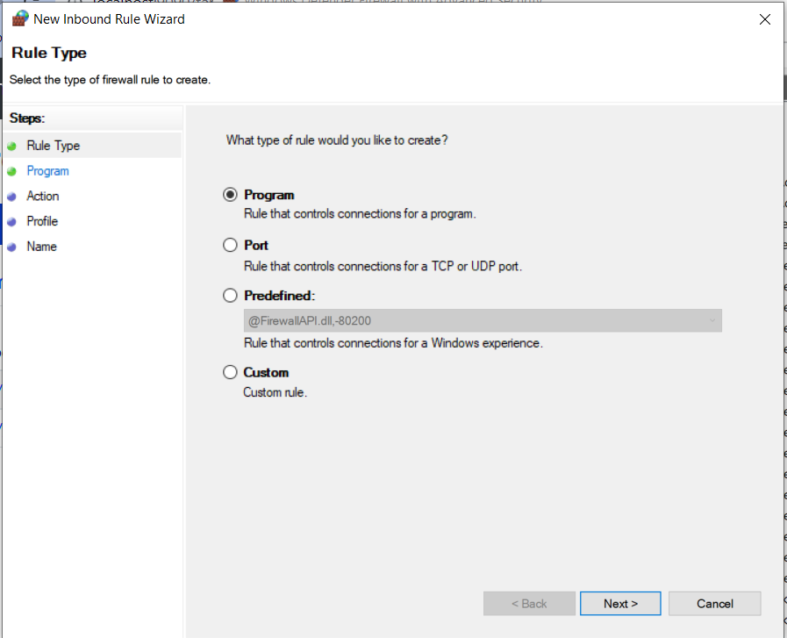

1. Select the browse option then find Prometheus executable you and select it. Click Next.

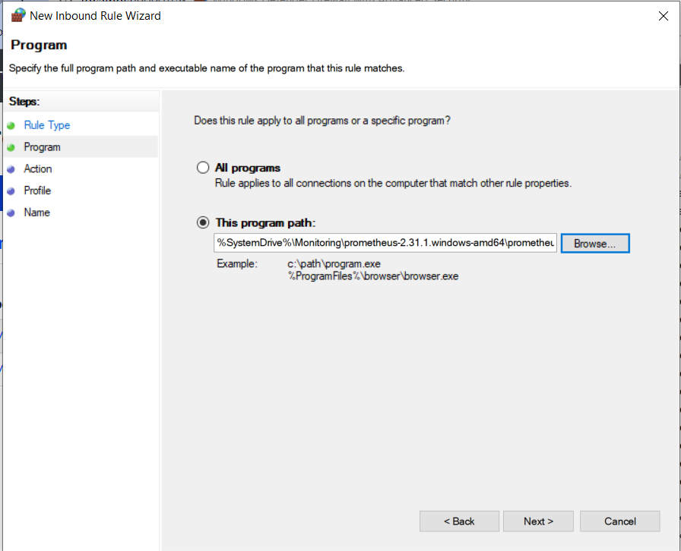

1. We want to make sure that Prometheus is always connected to our host since we are using it as a monitoring tool. Select “Allow Connection” and click Next.

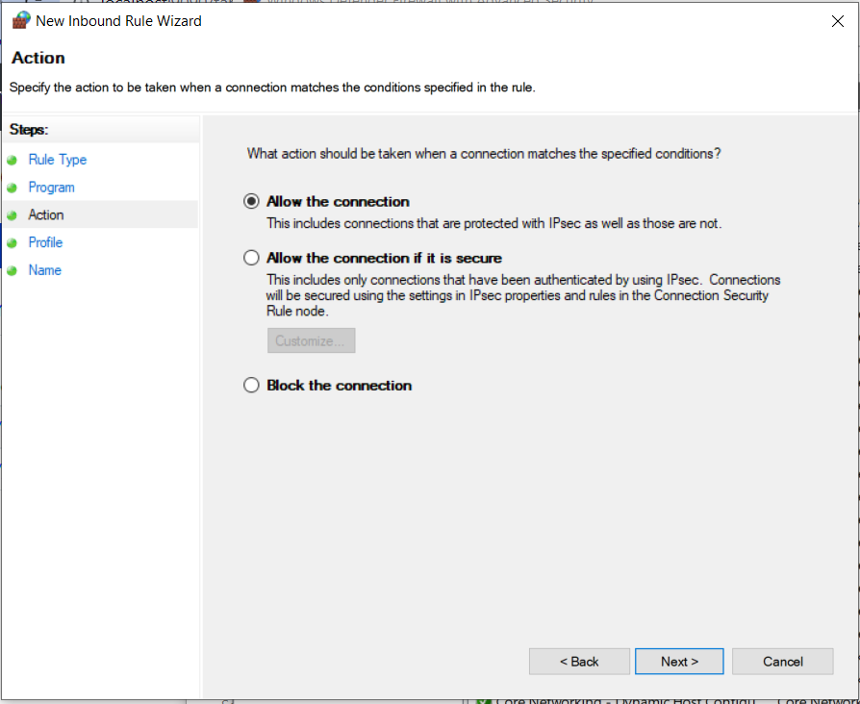

1. We want this rule to apply to all profiles. Click Next.

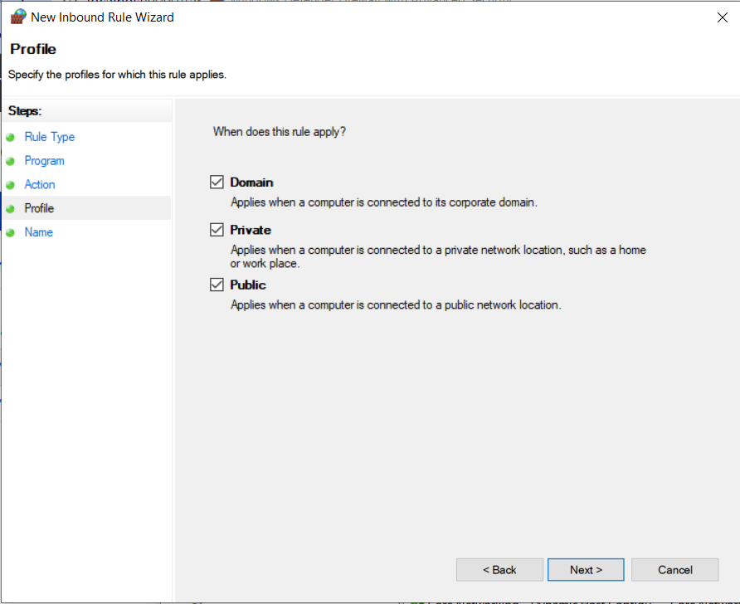

1. Name the Inbound Rule to something that is easily identifiable and a short description. This is an example of good documentation for future use. Click Finish.

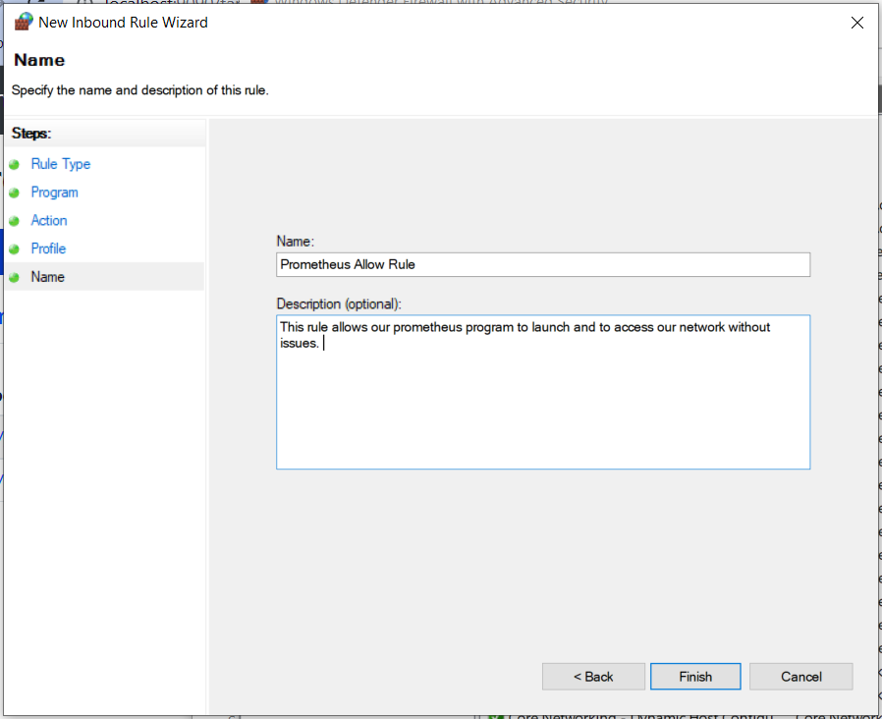

1. To create an Inbound Rule for ProtonVPN we just need to repeat Steps 4-8 but be sure to change the path to ProtonVPN. Like Below.

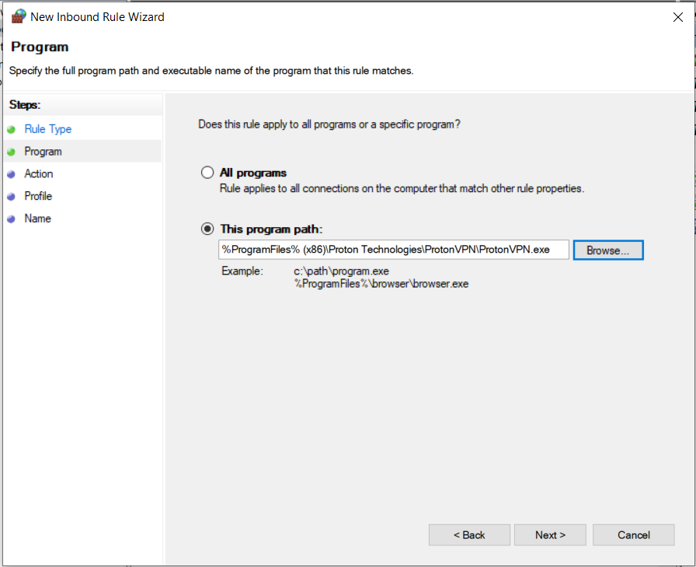

1. Just like Step 9, be sure to create an easily identifiable name for this rule so we know for which program this is.

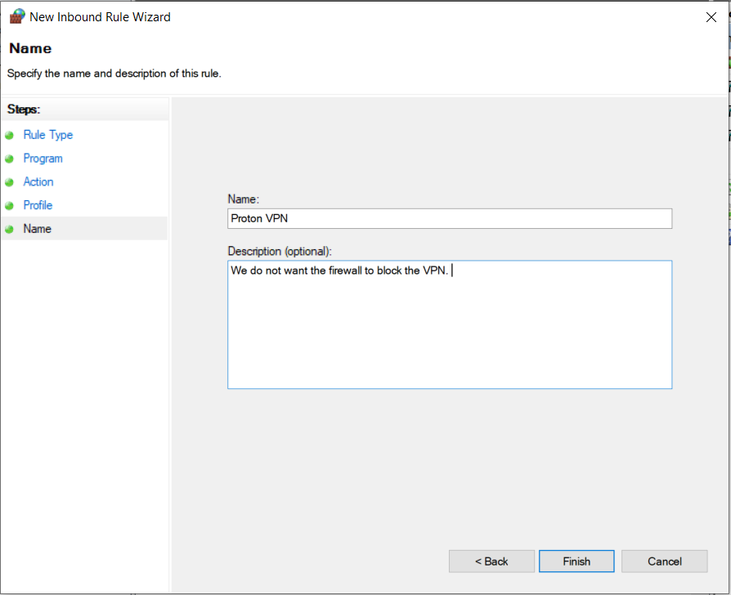

1. Now we will move to Outbound Rules. Most of the steps will be identical to creating an Inbound Rule. Select Outbound Rules on the left panel then select New Rule on the right panel.

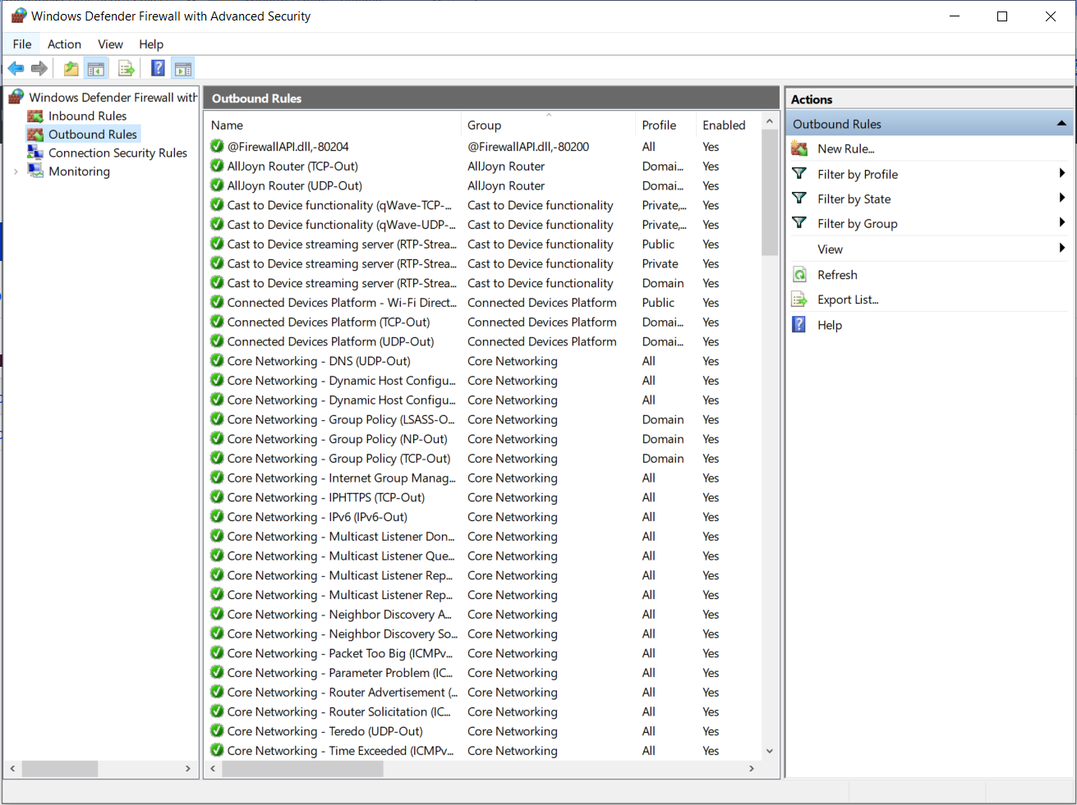

1. We will start with ProtonVPN this time, since it is a program we will continue with the Program option selected. Click Next.

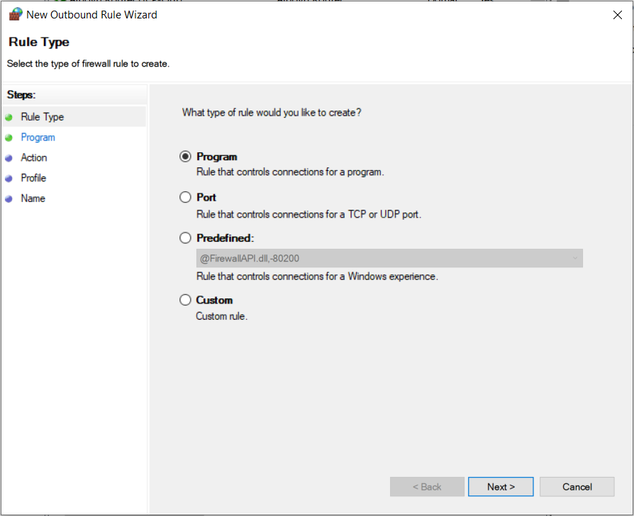

1. We will choose the same file path we used with ProtonVPN the first time. Click Next.

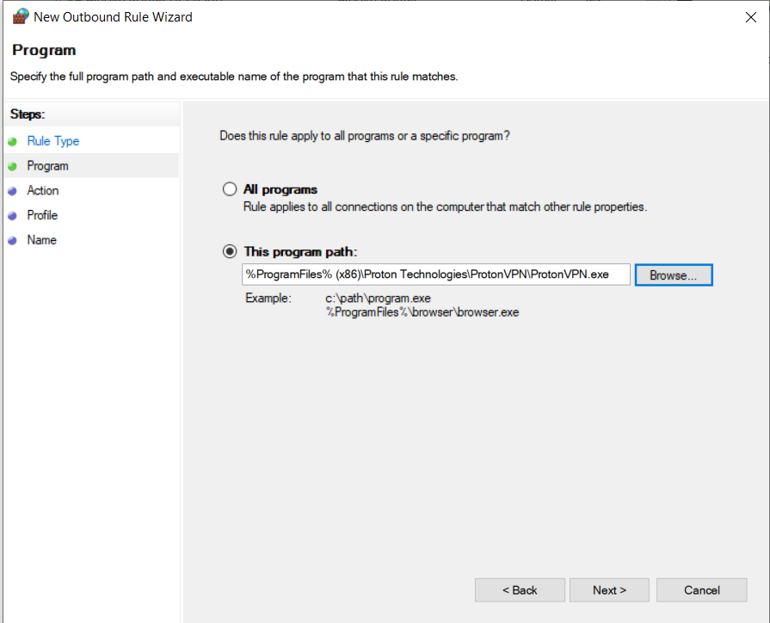

1. Make sure “Allow Connection” is selected so that network traffic can flow freely from the VPN through the firewall to the Host. Click Next.

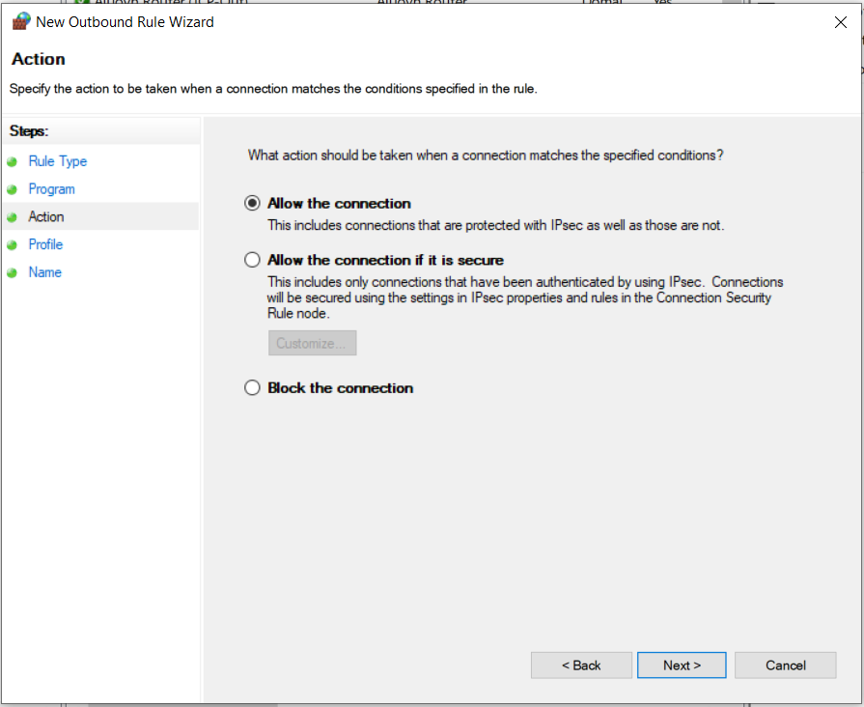

1. We want this rule to apply to all profiles. Click Next.

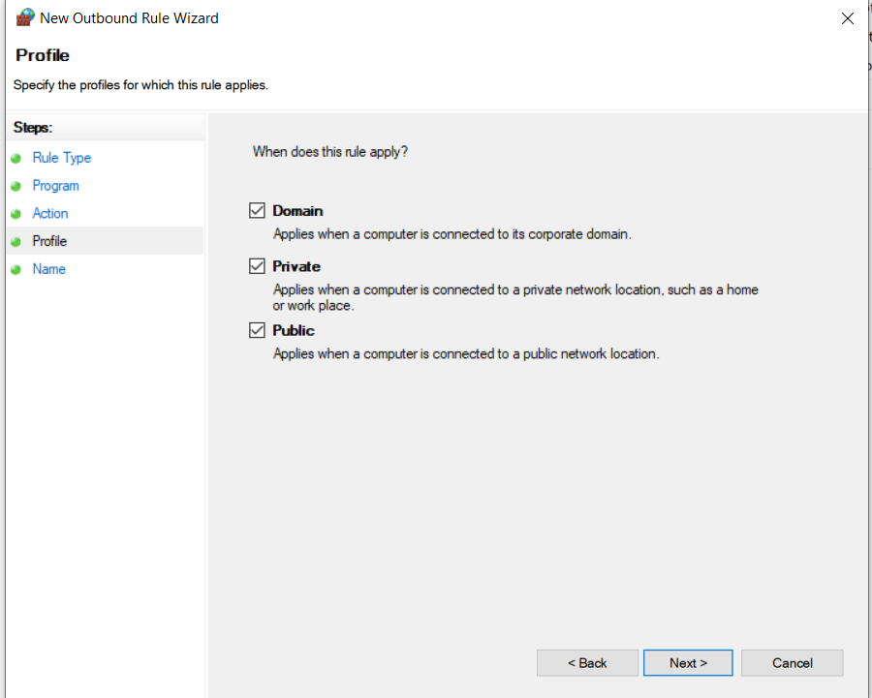

1. Be sure to create an easily identifiable name. Since we used “ProtonVPN” for the Inbound Rule, this time we will be more specific with “Proton VPN Outbound Rule” . Be sure to create a short description to ensure proper documentation for future use. Click Finish.

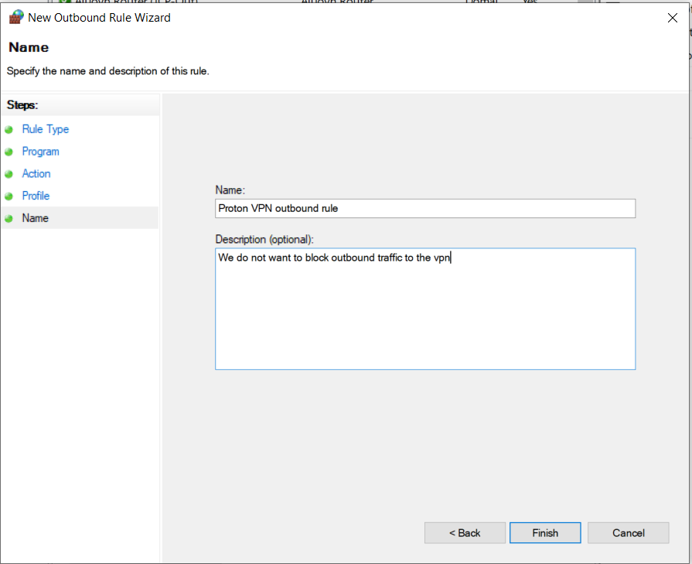

1. This time we will repeat Steps 12-17 but for Prometheus. Make sure to Name it and leave a description. Click Finish.

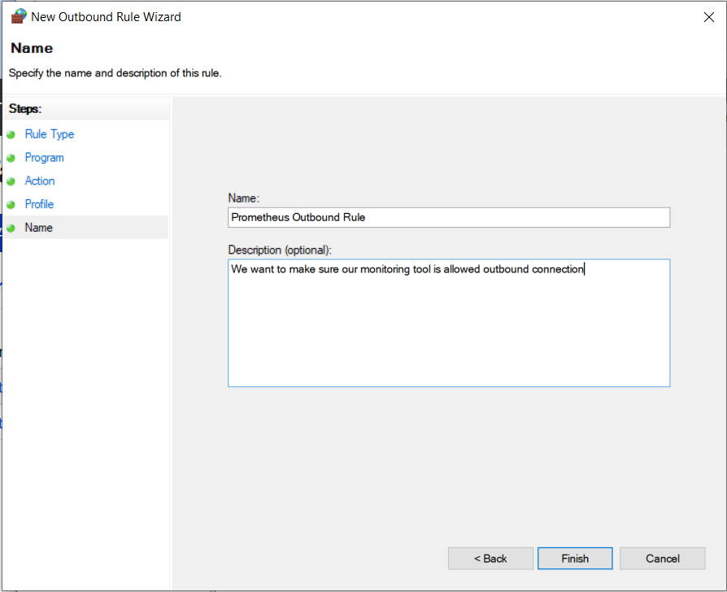

1. Back in the Home screen for the Advanced settings we will navigate to the right panel and select properties.

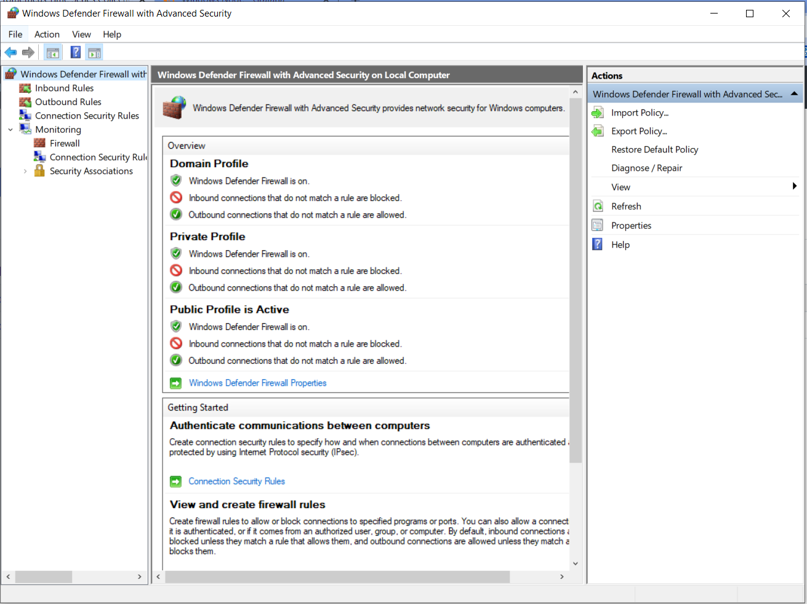

1. We will now select the public tab since we are using a public profile. We are using a public network and our employees can log into our wifi, so we will use the public profile with the most restrictive security settings.

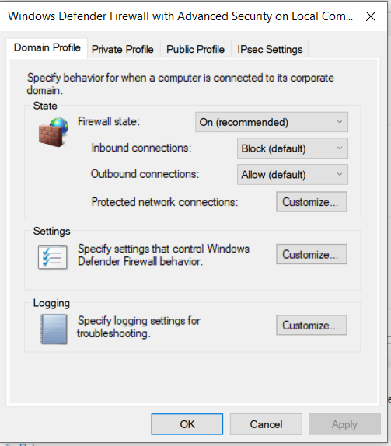

1. Now we will select the “Customize” option right next to logging.

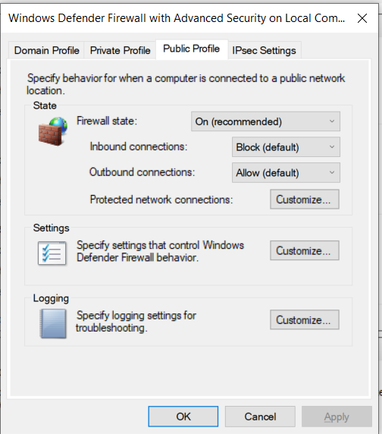

1. We will not be changing the location where the logs will be stored and we will not exceed 4mb of logging size limit. Since we want to log dropped packets and successful connections we will change the default options to “Yes”. Then Click Okay. We have now successfully allowed for logging with our Windows Defender Firewall.

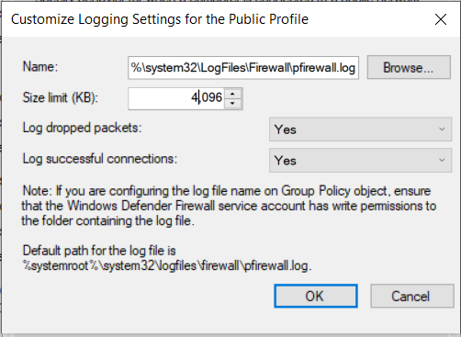

### Testing

1. We will now test that our firewall is logging in the location we have specified. We will go to our C:Drive-> Windows Folder-> System32 Folder-> LogFiles Folder-> Firewall Folder. Now we will see pfirewall. If we refer to the Step 22, we will see that it is the correct location we want our logs. Navigate the internet for 5 minutes so that we can be sure that the file will be populated.

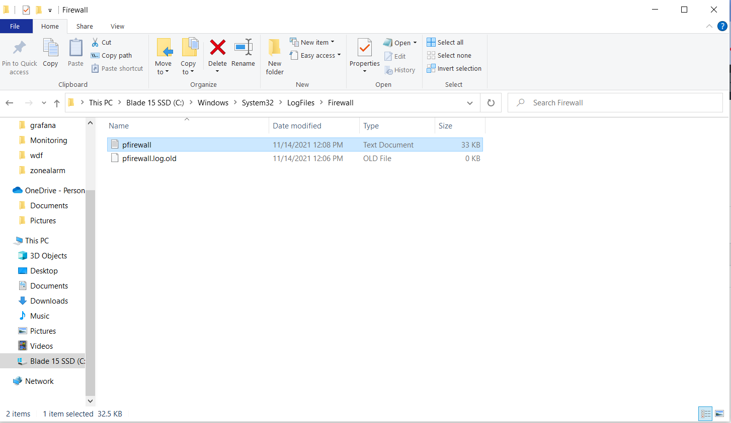

1. After 5 minutes we will open the folder. There should be evidence of traffic in our network in our log. We will now be able to see the time, if the traffic was allowed or denied, protocol used, IP and whether packets were sent or received.

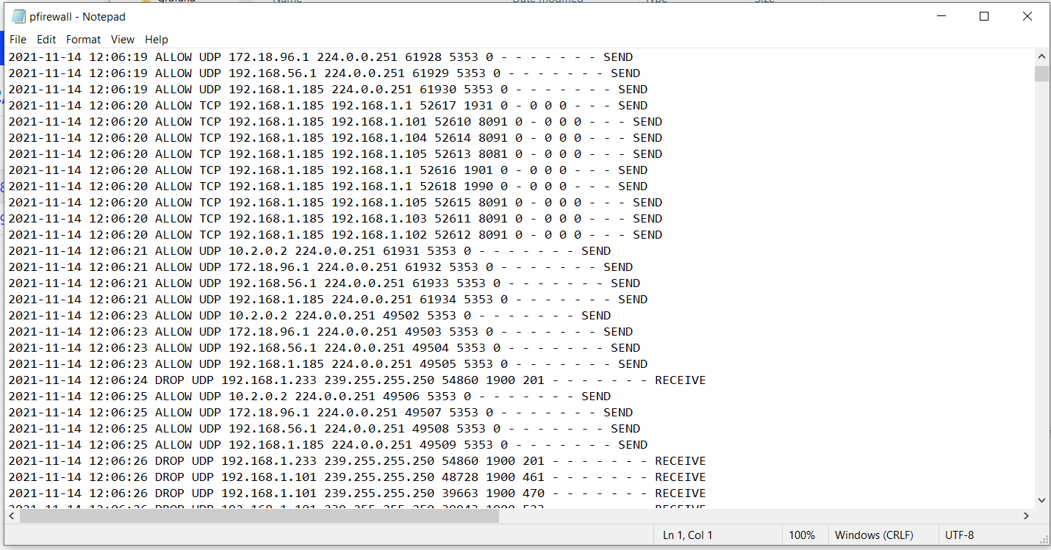

1. Now we will go to our browser and type “localhost:9090/metrics” to see if Prometheus can capture packets,and we can see this as shown below.

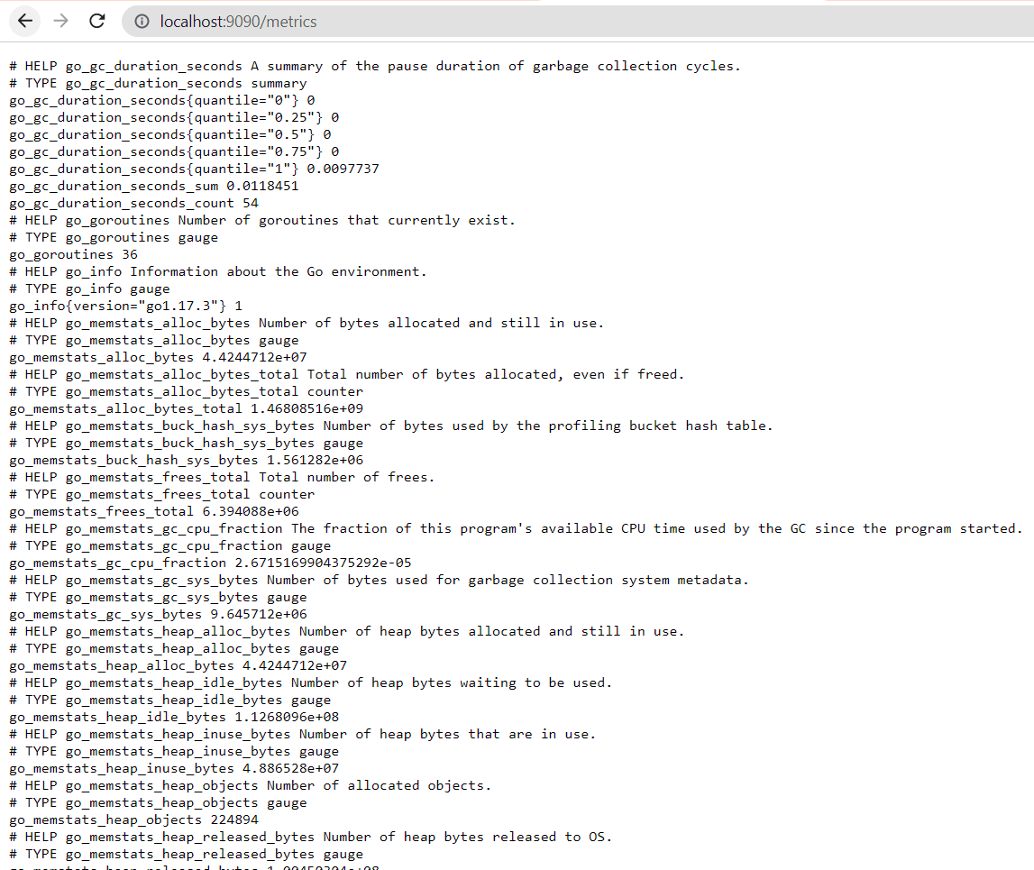

1. We will try to connect to ProtonVPN by opening the application and clicking “Connect”. Another success, our rules and logs are working just fine.

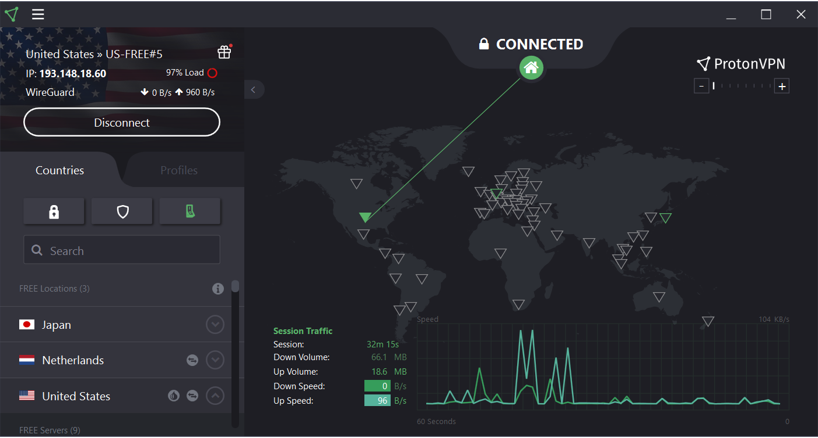

1. While the Prometheus and ProtonVPN may be able to function without the Inbound/Outbound Rules we want to make sure that we maximize their functionality so that our firewall doesn’t accidentally deny traffic to them and compromise our security.

## Recommendations (Kari)

Windows Defender Firewall is a built in Windows security tool that is on by default. However, maintaining the default settings on this tool is not considered best practices. During this lab we worked towards hardening the firewall to improve its security and to set it to generate log files. With this hardening will require some upkeep in the form of new firewall rules, new log files, and backing up those log files.

Configuring New Rules: New rules will need to be configured if new malicious activity is detected within the network. These rules can be used to block IP addresses and ports associated with the malicious activity.

New Log Files: We have configured Windows Defender Firewall to save activity into a log file. Log files are used for forensic investigation after an attack has taken place and to keep record of activity. These log files are configured to be just over 4 MB. Once the log file has reached this size, the tool will stop recording the logs. This will require a user to create a new log file for record of events to be saved to. This can be accomplished in the same way that logging was configured, but simply changing the filename in the file path. To ensure that no events are missed a schedule should be established to create a new log file weekly or monthly to ensure all events are logged.

Backup Logs: Logs are used to explore activity after an attack or unusual activity has been detected. It could be relevant to explore logs months even years earlier. To ensure that access to these logs are maintained there needs to be a backup schedule established to upload all log files to a secondary device, either external drive or the cloud. Doing this will ensure that in the case of an event that prevents access to a device, the log files are still accessible.

## Alternatives (Marcos)

Avast Premium Security is another cross-platform antivirus security suite that offers protection against malware and cyber threats. It also includes useful security features such as an Advanced Firewall that monitors the network activity and instantly notifies our users with alerts if malicious traffic has penetrated our network. It has a low performance impact on our systems while the software is running in the background of our workstations. The platform is compatible with all major operating systems, such as Windows, macOS, Android, and iOS devices. It offers multi-device subscription plans; the freeware, Avast Free Antivirus costs nothing, but it is very limited in essential security functions. The next tier which Ashburn’s Frog Emporium is considering as an alternative firewall, is Avast’s Premium Security. This plan contains the necessary features for our network such as a firewall, advanced antivirus, web shield, Wi-Fi inspector, ransomware shield, and password protection. The premium security suite costs $69.99 per year per device with the option of increasing the amount of devices, however this will generate more cost for our company. The Avast ultimate suite comes with all the features from the premium, with the addition of a secure VPN, a passwords premium allowing for fast-tracked logins to websites, and an enhanced file clean-up tool. The ultimate suite cost $99.99 per year for one device, with the ability to increase the number of devices needed to be protected. The more devices we add to the subscription, the more Ashburn’s Frog Emporium would have to pay. In this case, we will continue to use and harden our built-in Windows Defender Firewall we have implemented. The Ashburn’s Frog Emporium would benefit from Avast’s impressive feature set, good malware protection and minimal impact on system performance. We would recommend implementing this platform Firewall function to further strengthen our network and protect it from unwanted traffic.

# ZoneAlarm

## Information About Tool (Ryan)

ZoneAlarm is a Firewall and Antivirus monitoring solution that is designed to protect its user’s PCs against viruses, spyware, and hackers. Owned by CheckPoint Software Technologies LTD and was first released on February 16, 2000, ZoneAlarm uses Stateful packet monitoring as a basis for its technology. ZoneAlarm brings two of the most important cybersecurity tools together in a single interface, a Firewall and antivirus software.

One of the things that sets ZoneAlarm apart from its competitors is how it handles zero-day attacks through the use of Threat Emulation. Threat Emulation allows for traffic that the system is unsure about to send that traffic to a virtual machine. One it is there the traffic is able to be observed to make sure it is safe before allowing it into the actual network. This feature is available to all tiers of users and is key in stopping malicious traffic.

The antivirus functions of ZoneAlarm work by using scheduled or on demand scans that are based on the predefined rules that are crafted by the network administrators. This antivirus software not only scans for virus and malware signatures however, it also can perform heuristic scans. These scans allow the software to examine the behavior of the file to determine if it performs and acts as the scan believes it should. If the behavior is hostile or is unwanted in the network, ZoneAlarm can automatically treat the issue and Quarantine the file so it can not harm the system.

## Prerequisites (Ryan)

* The following operating systems are supported by ZoneAlarm
  + Microsoft Windows 8, 8.1, 10
    - 32-bit or 64-bit
    - 2 GB of Ram
    - 1.5 GB of hard-disk space
    - A process that is 2 GHz or faster
  + Microsoft Windows 7 SP1
    - 32-bit or 64-bit
    - 2 GB of Ram
    - 1.5 GB of hard-disk space
    - A process that is 2 GHz or faster
  + Microsoft .NET framework
    - Version 3.5 or later
    - If this is not installed when ZoneAlarm is first implemented, it will be installed with ZoneAlarm.
* ZoneAlarm also is only compatible with MS Windows Defender. In order for ZoneAlarm to install causing stability issues is to uninstall all other antimalware software first.
  + Windows Defender Firewall requires the following operating systems
    - Windows Vista
    - Windows 7
    - Windows 8
    - Windows 10
    - Windows 11
    - Windows Server 2008
    - Windows Server 2008 R2
    - Windows Server 2012
    - Windows Server 16 or above
* There are specific features in ZoneAlarm that have requirements for the internet browser one uses
  + Anti-Keylogger
    - Microsoft Internet Explorer 7, 8, 9, 10, 11
    - All versions of Mozilla Firefox
    - All versions of Google Chrome
    - Opera versions 15 or greater
    - All versions of Apple Safari
  + Anti-Phishing Chrome Extension
    - All versions of Google Chrome

## Instructions (Luis)

### Installation

1. Earlier in the Lab we configured and tested Windows Defender Firewall as our host based firewall. In this section we will install, configure and test our main Firewall which is Zonealarm. Zonealarm offers free antivirus software and a firewall as well as identity protection. After the installation and configuration is complete we will test if Windows Defender Firewall and Zonealarm can protect our network. To begin go to zonealarm.com/software/free-antivirus/release-history we will be installing version 15.8.181.18901. This tool is fully compatible with Windows 10 and our Windows Defender Firewall.

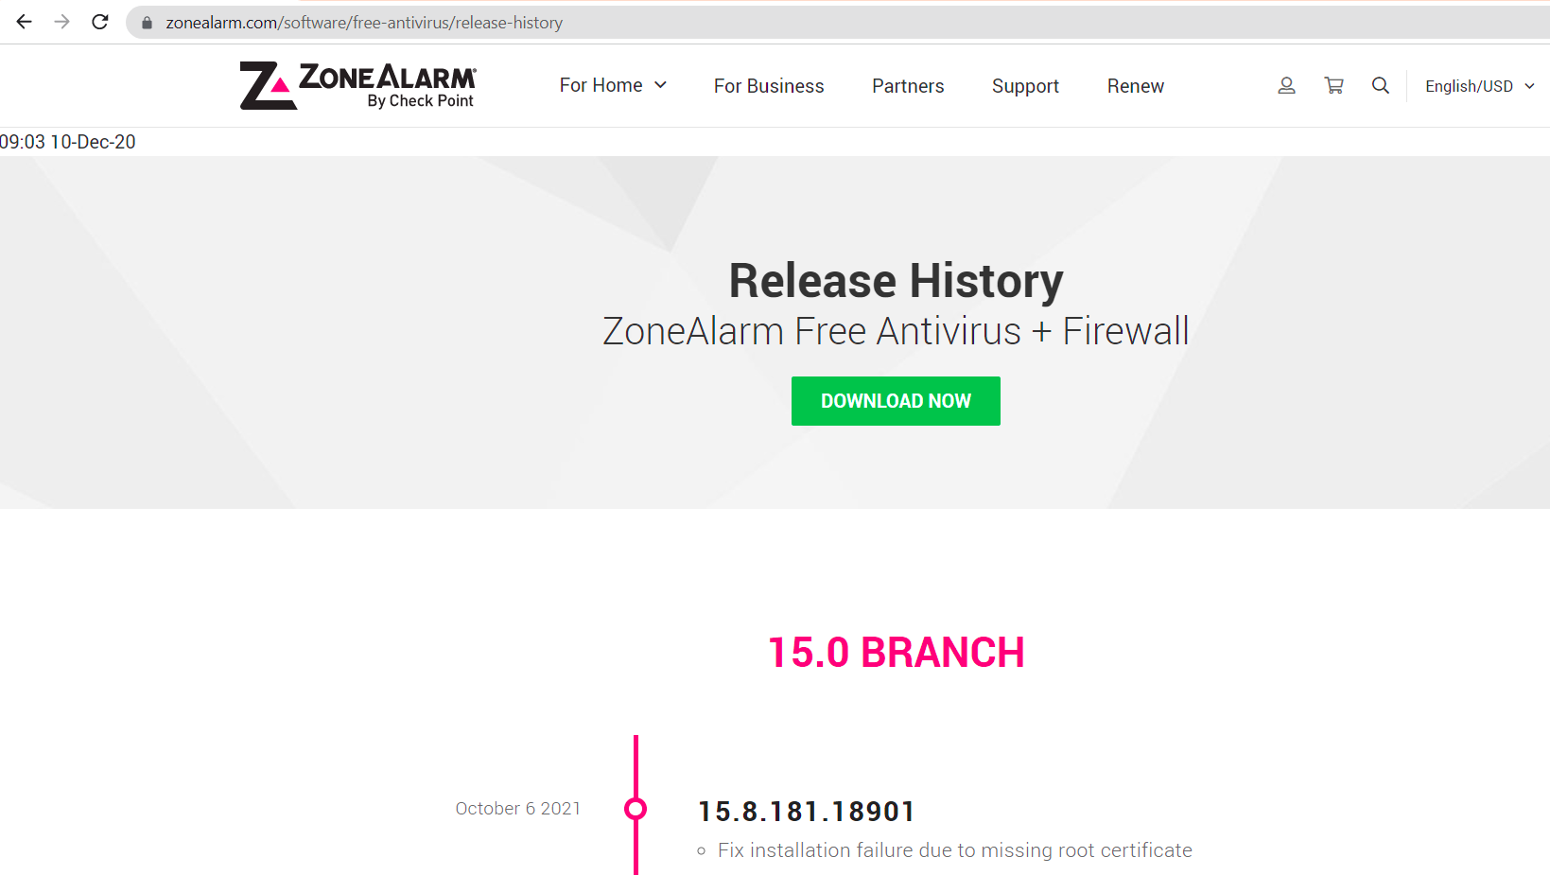

1. Once downloaded, verify the file. 158_181_18901 will indicate the version we are using.



1. Click the check mark after reading the privacy policy then begin with “Quick Install”

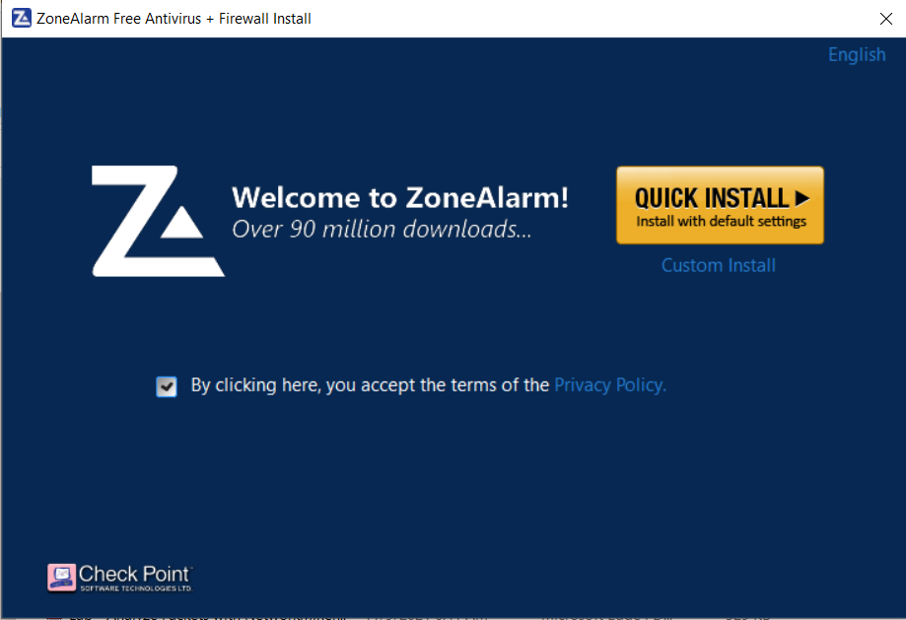

1. Read the User License Agreement then click Agree.

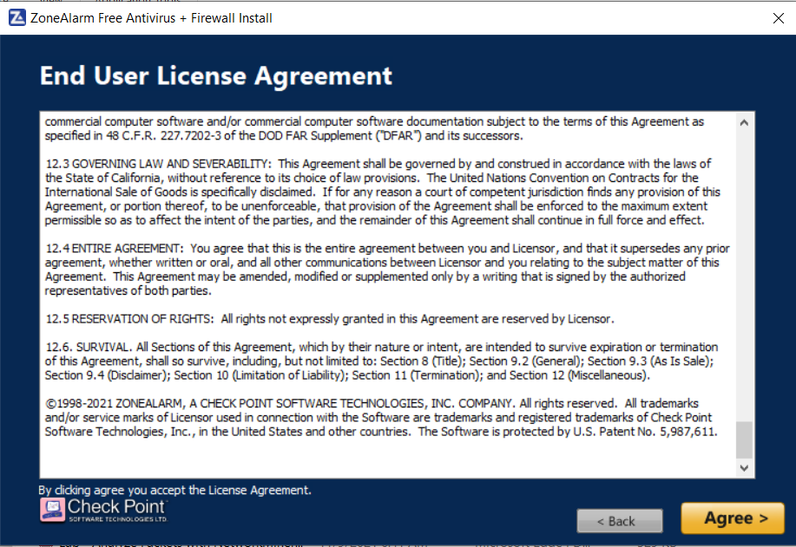

1. Click skip when prompted to install a chrome extension, we just want to install the antivirus and firewall for now.

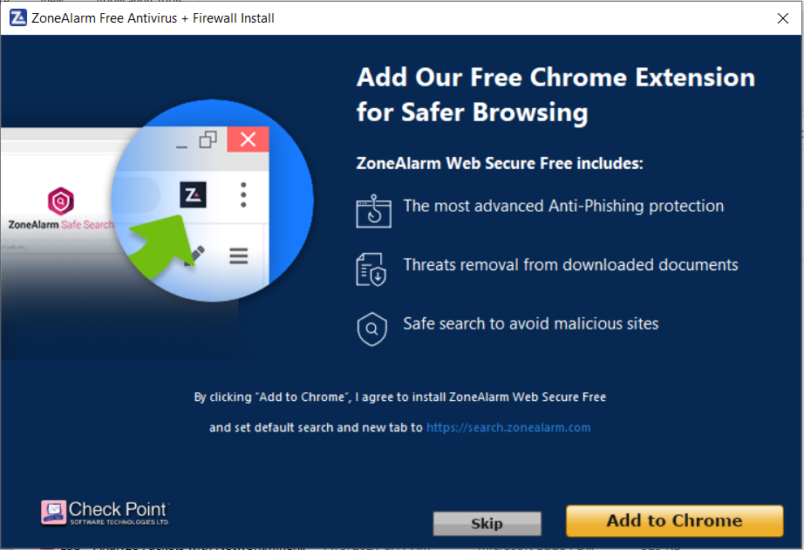

1. The download will begin and wait until it is finished.

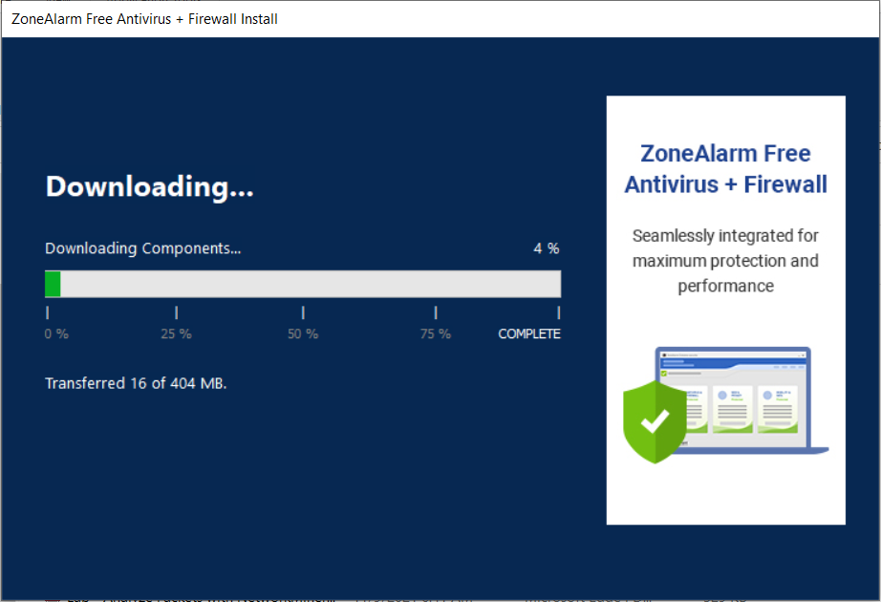

1. DO NOT ENTER YOUR EMAIL! Click Finish once the installation is complete.

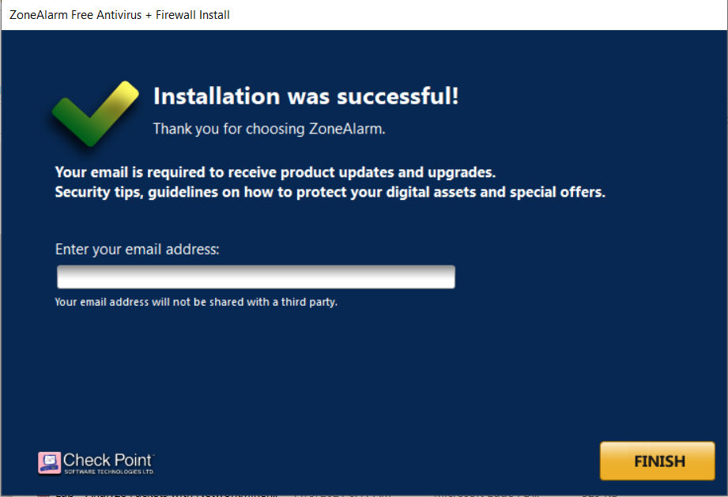

1. Click Yes to restart your computer.

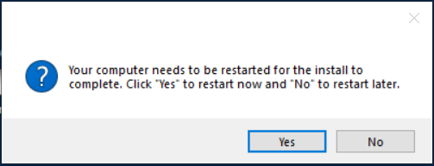

1. Once you have restarted your computer and log back in, launch ZoneAlarm if it didn’t automatically launch itself. It should launch on startup. On the Home screen you will notice three panels: Antivirus, Firewall and Mobility.

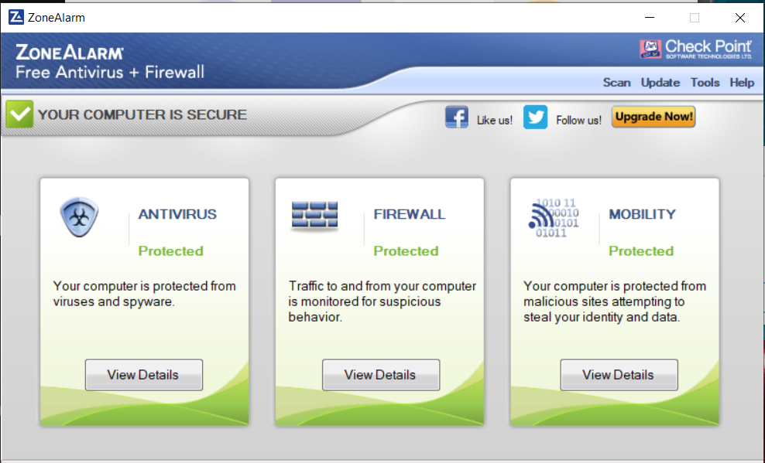

1. Click “View details” under Antivirus. This will allow us to see scan results, schedule scans, and toggle the anti-virus as well as to customize the settings.

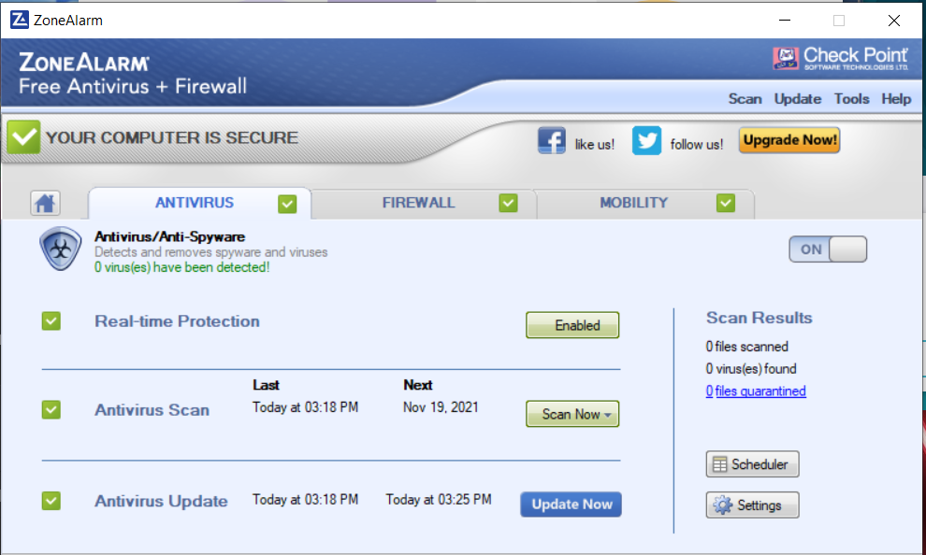

1. Next, click on the Firewall Tab. This will show the attempts blocked, programs secured, customize settings and toggle the firewall on and off.

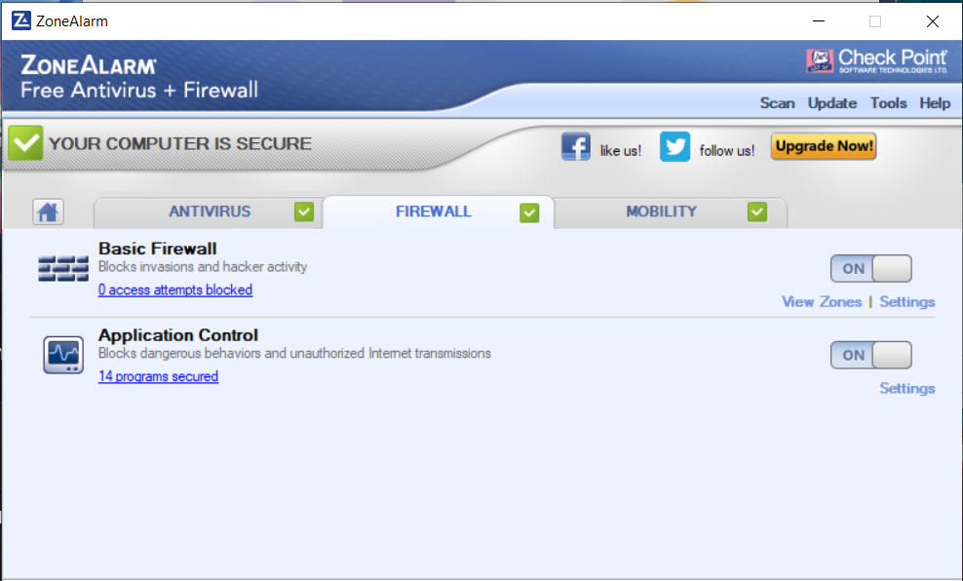

1. Next click on Mobility. This will allow us to set up Identity Protection and protect private information from being leaked online or accessed through unwanted applications.

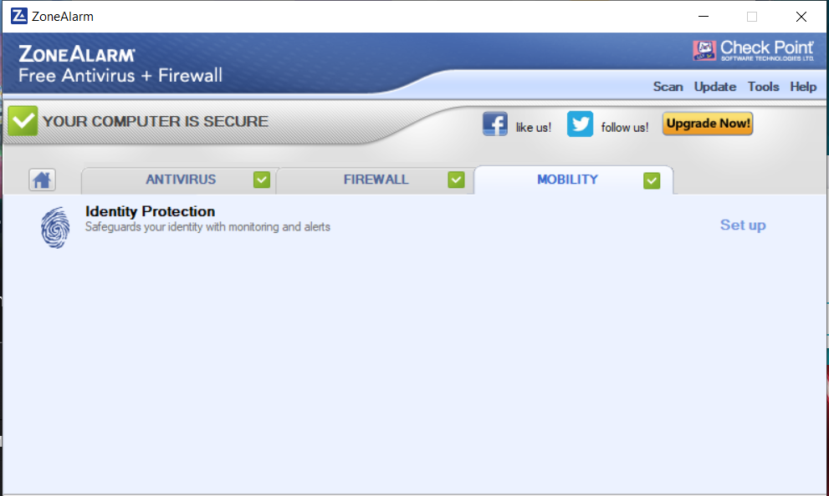

### Configuration

1. The first step in configuring our firewall/antivirus will be to set up identity protection. We will click on the Mobility tab.

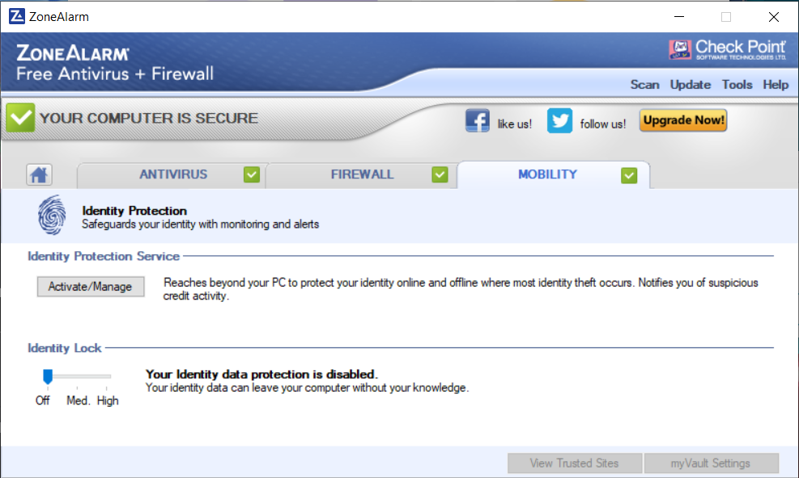

1. We now notice that our identity data protection is disabled by default so, we will first slide the option to High. Now, we will click on activate/manage to protect against PII leaks.

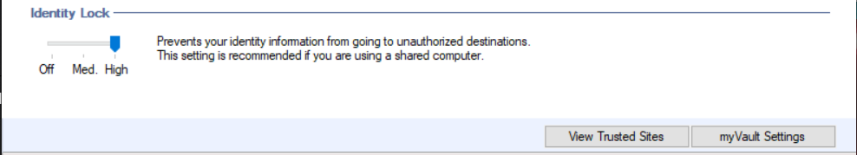

1. We will see that there is nothing in the vault for now, in the bottom of the screen, click “Add”.

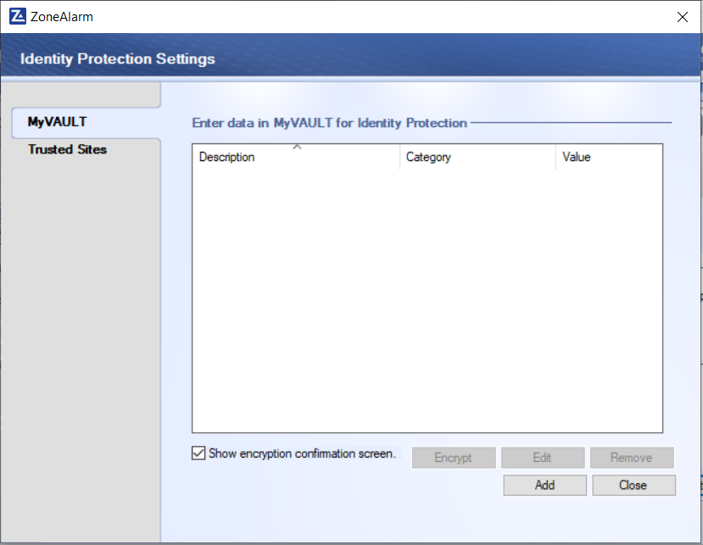

1. We will be able to set a description of the data we want to protect and choose a category as well, to begin we will start with an email address. Look at all the category options available. Make sure that each item added will have “One way encryption” check marked. This will enhance our data encryption standards so now we are encrypting it through our firewalls, with veracrypt at rest and with ProtonVPN while in transit.

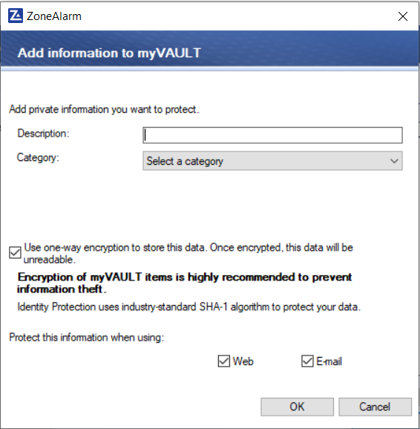

1. For now, enter a generic description such as “email address” and then add the email address you want to protect. Then click “Add”

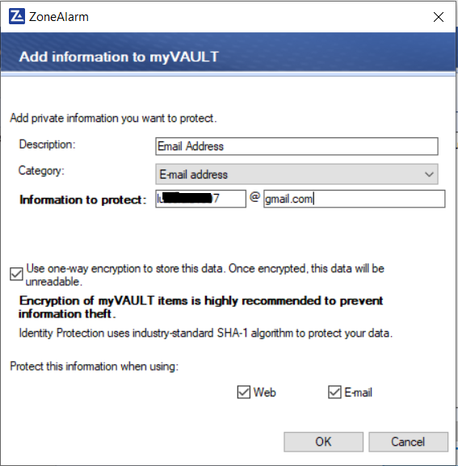

1. Pretty easy right? Now in the home screen click “remove” and it will be removed. Now, we will repeat this process but change the category option. It’s a very simple and straightforward method and to save time we will not be going through each category. The information we want protected will be Ashburn Frog Emporium’s account password (banking password), Black Card (business credit card), Employee 1 and 2’s Social Security Number and Names, and then the Business’ bank account number, Ebay password, Business email address, and Tax ID. Again, by clicking the category the “Information to Protect” field will change and it is very straightforward.

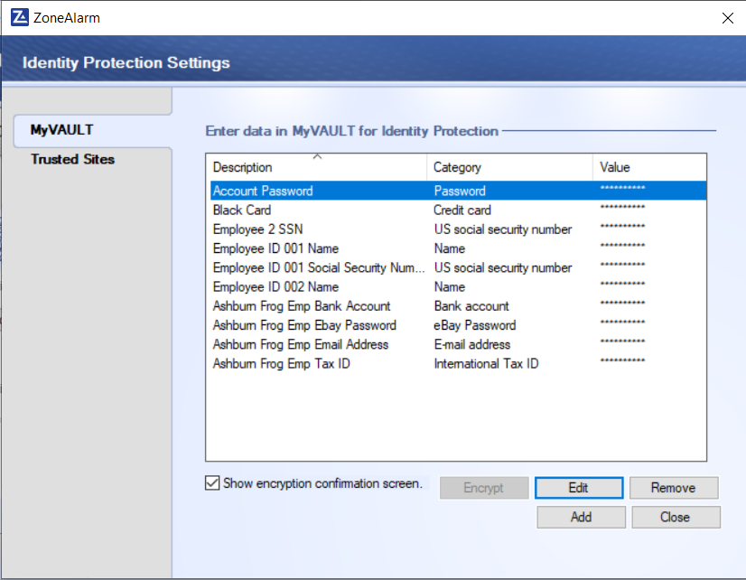

1. Next, we will click on the bottom tab “Trusted Sites”. As a default, one site will already be added, this should be Paypal and it should have “Access” and “Clear Text Password” allowed. This is not recommended and we will be changing this and adding more Trusted Sites.

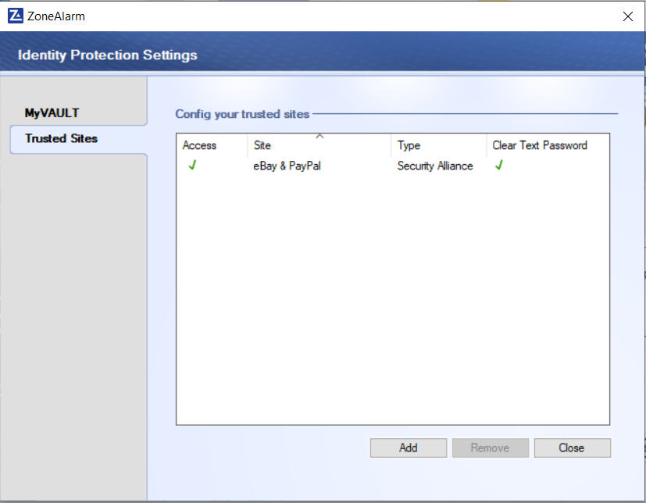

1. First we will click Add. On the new screen we will type in the URL for a site we want as trusted. Since the Owner of Ashburn Frog Emporium is an Alumni from GWU School of Business we were asked to add GWU as a trusted site.

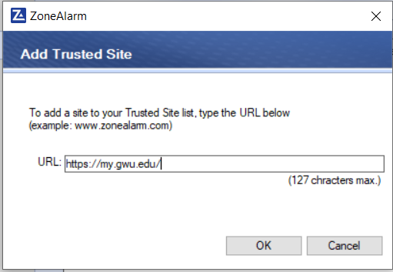

1. When a site is added it will have blue question marks. As a default, trusted sites when added, will ask the user each time data is being transmitted if it is allowed to pass through the site or not.

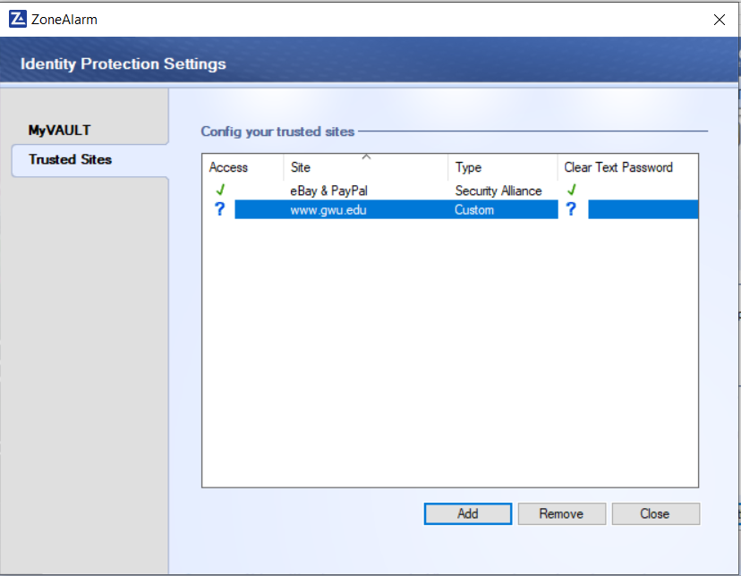

1. Since the Owner does not want to be asked each time they are accessing GWU’s site, we will now change both the access and clear text password to allow.

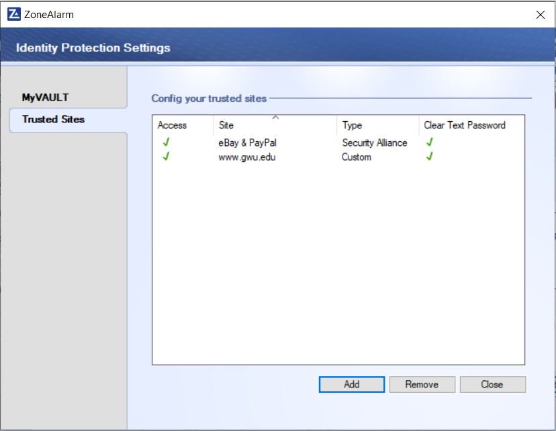

1. Now we will repeat the process from Steps 7-10 and add Youtube, Linkedin and Facebook to our list. We will also change Ebay’s and Linkedin’s clear text password to secure the password, will also set Youtube to ask before sending myvault information and ask whether the password will be in clear text. Facebook will be denied access and the clear text password will be denied. Click Close.

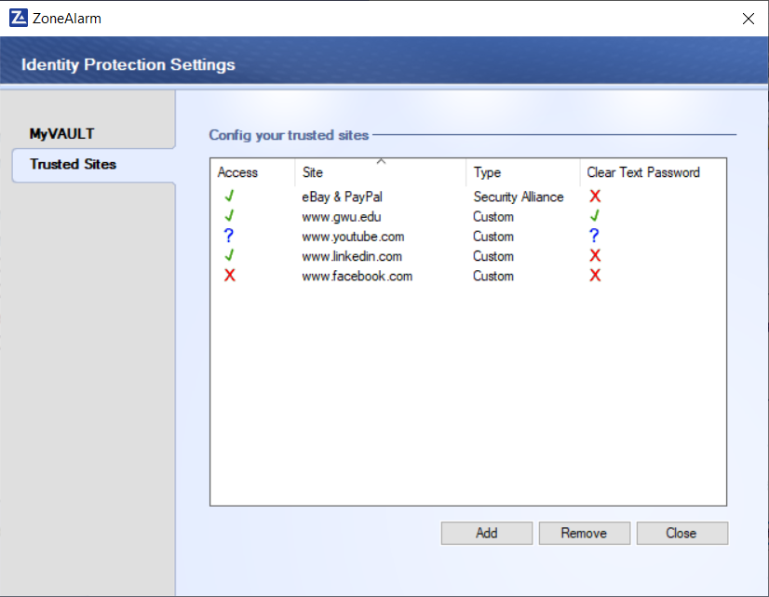

1. Next Click on the Antivirus Tab and click on “Scheduler”

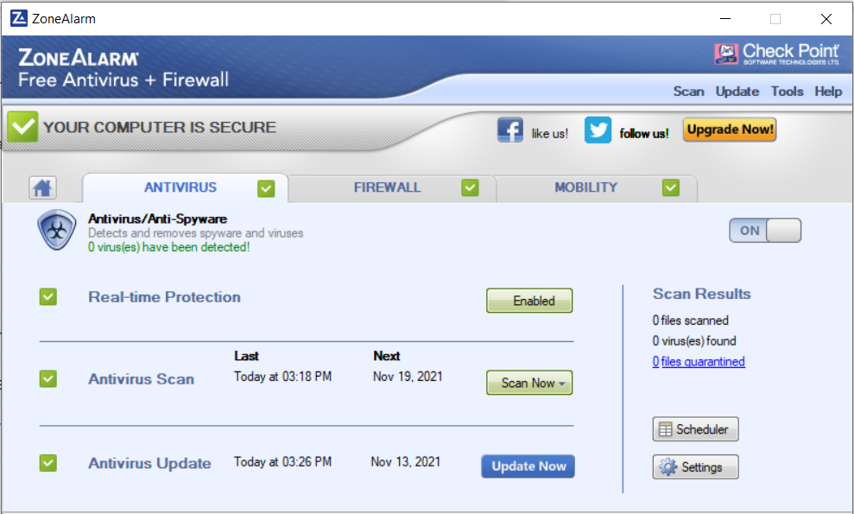

1. As a default, quick scans are conducted every 7 days and a full scan every 3 months. We will change the frequency to 1 day and Every month. Click Okay.

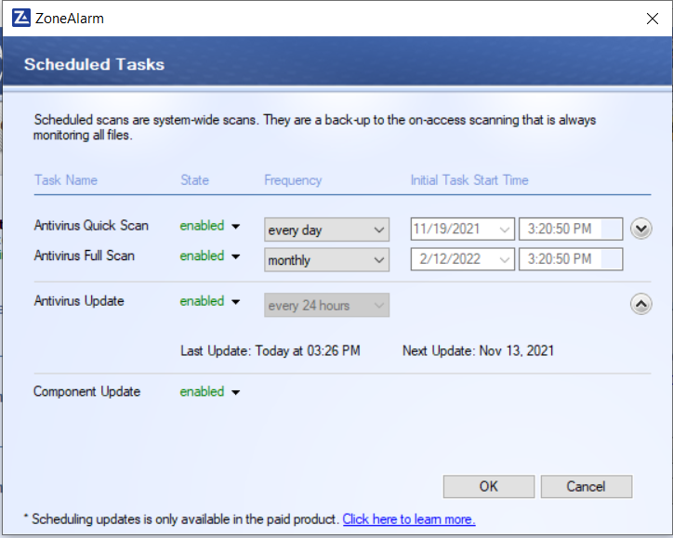

1. Now you will see the next scan date will change to the following day. This way our Antivirus is up to date to the latest version possible.

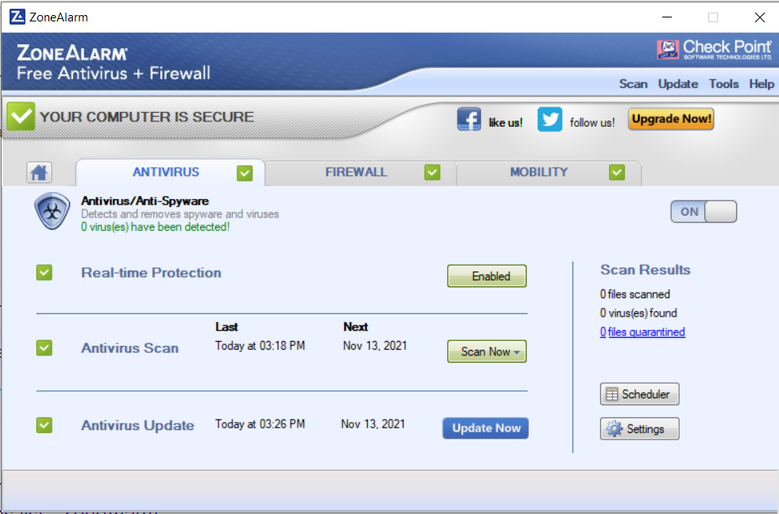

1. Next we will click on the Firewall tab. Our Public Zone security is High, if you recall to Windows Defender Firewall then you will notice that we are also on a public profile. This is good, we will leave it on high. Change the “Trusted Zone” security to High as well.

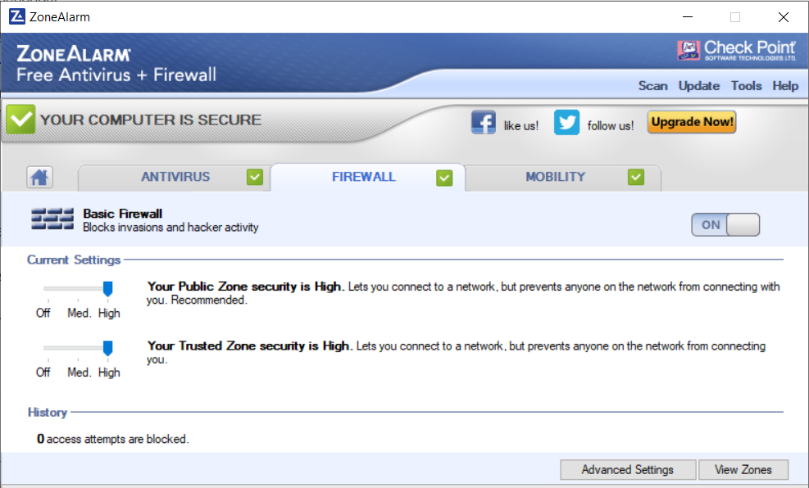

1. Next we will click on “View Zones”

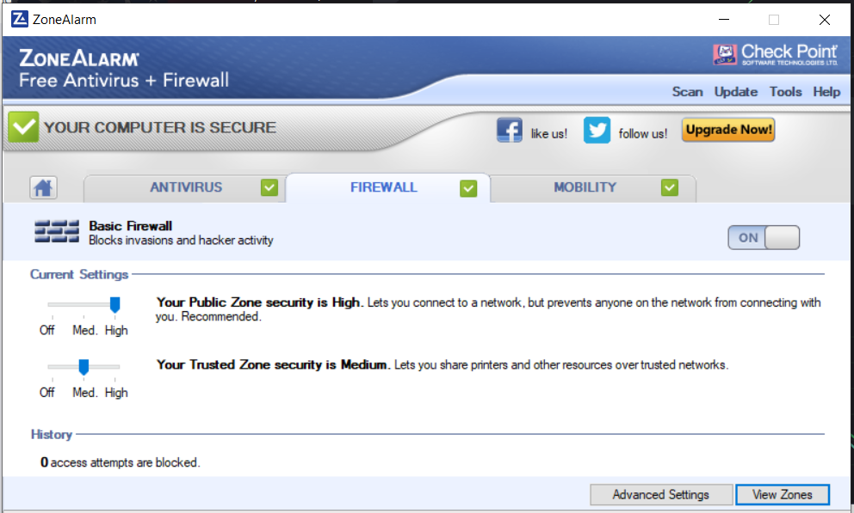

1. Click on the “Advanced” tab. Just how we configured Inbound/Outbound rules with Windows Defender Firewall, we will click on “Allow VPN Protocols” so that Proton VPN can operate through the firewall. Also enable “Arp protection” and “filter packets over 1394”. Next, go to ProtonVPN and disconnect it (as shown previously) and then click on View Zones.

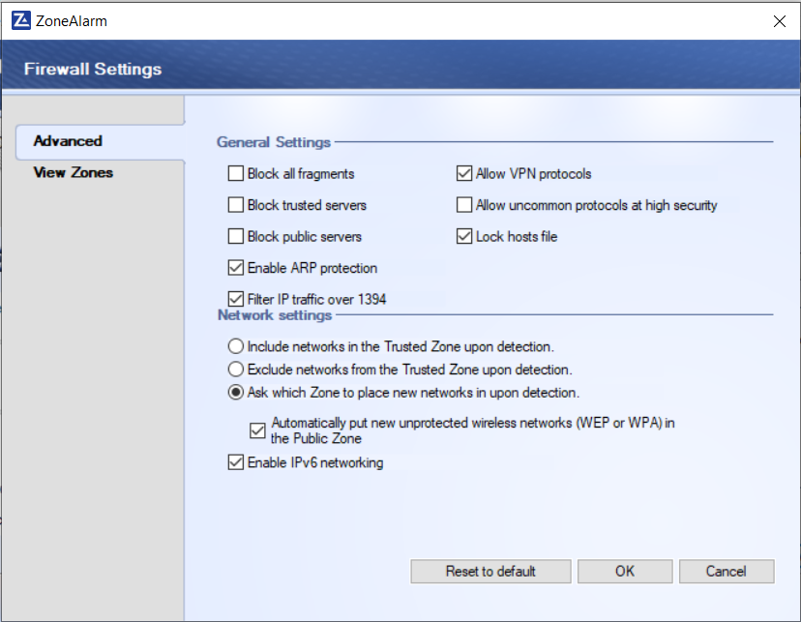

1. We will now see multiple networks associated with our host computer, this will include the private IP and networks connected to the host.

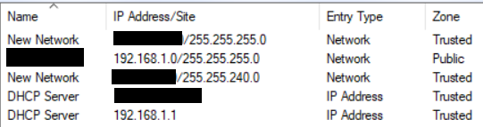

1. Connect ProtonVPN now we can compare that to the previous results. By default ProtonVPN will show up as “New Network” ; the one that was not previously shown is ProtonVPN. Click the new network and click on Edit.

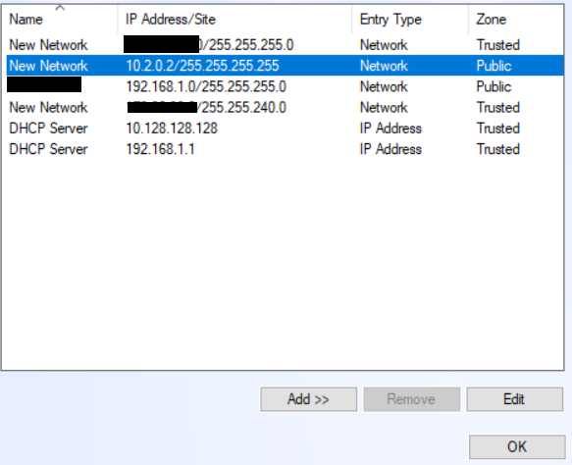

1. Change the “Description” to ProtonVPN and click Okay.

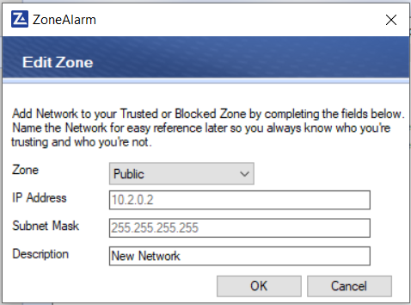

1. Now you will see that ProtonVPN will show up with the correct network name. Click Okay.

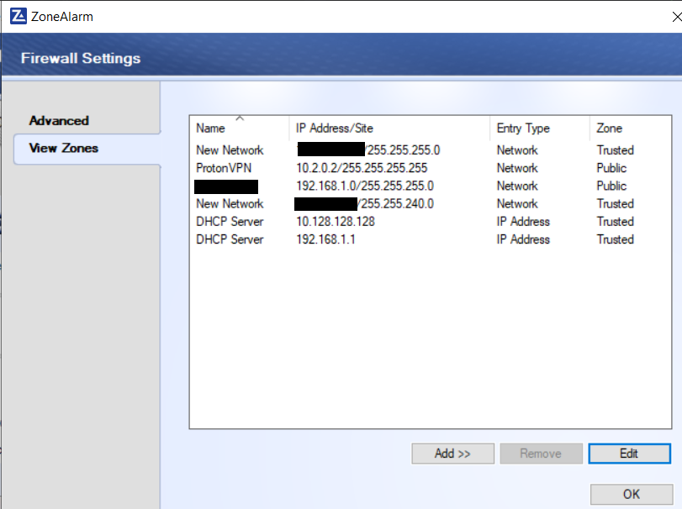

1. Next click on settings under application control.



1. Change Network firewall to screen all applications and DefenseNet to be on auto.

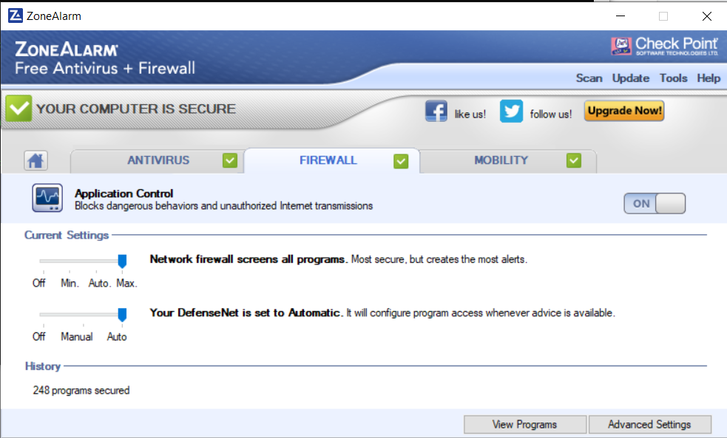

1. Next click on “Advanced Settings” and click on the OSFirewall tab, make sure it is checkmarked.

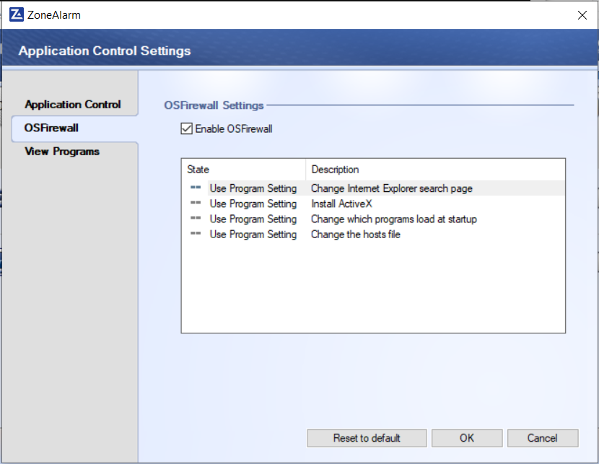

1. Click Okay then click on the Firewall tab again.



1. Click on “0 access attempts blocked” click on “Alert Events” tab and configure the settings as shown below. We do not want to be overwhelmed with logs and alerts so we will only choose the most vital.

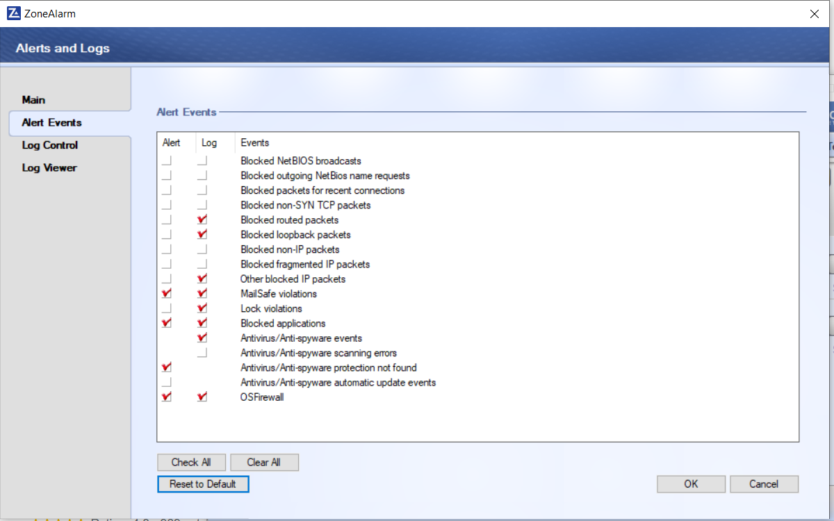

1. Next Click on the “Log Control” tab. Make sure it will be archiving logs every 7 days. We can also view and save log files through here or delete them if they get too big. It is very similar to Windows Defender Firewall.

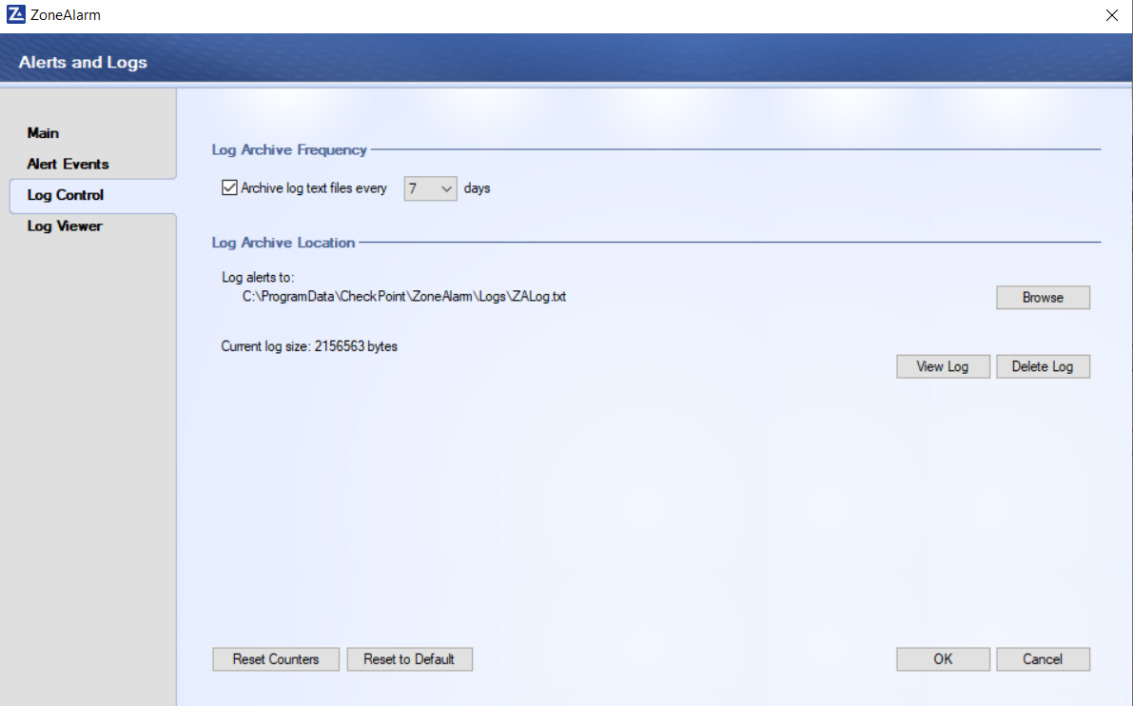

1. Next Click on the “Main” tab. Make sure Logging is on, Alerts shown are on medium to not overwhelm us but we are getting all the program alerts so unauthorized programs do go through our firewall. We have now configured our Identity Protection, Firewall and Antivirus and can now begin testing.

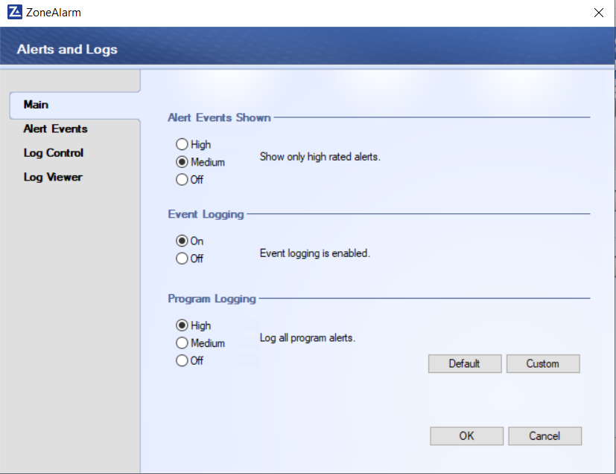

### Testing

1. To test the firewall just go on Youtube or any site with lots of network traffic for 30 minutes then return to the Firewall tab. Refresh it if necessary but now you will see that there were 704 access attempts blocked in those 30 minutes. The firewall is working but now let's check it.

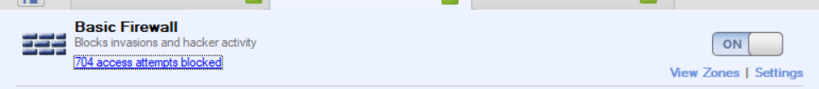

1. Go on Log Viewer as shown in previous steps. If we click on “Select Log type” and choose “OSFirewall” we will see which programs were launched by our host during that time.

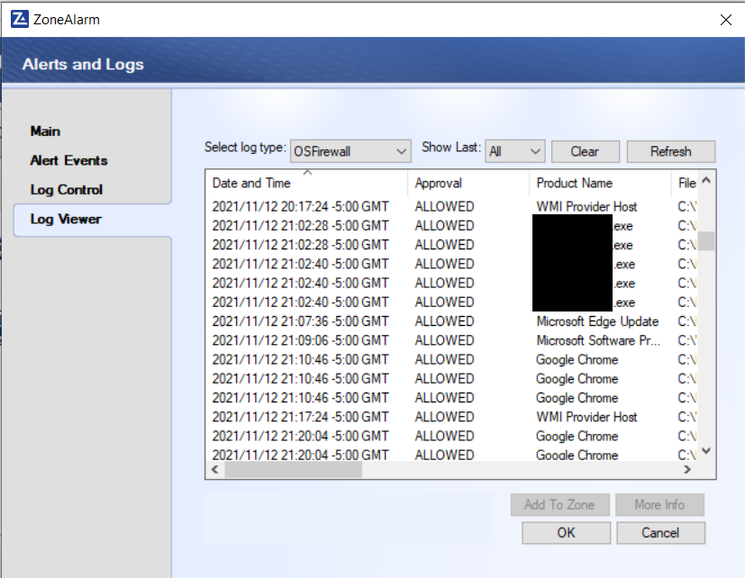

1. Click on the “Product Name” and “Microsoft Edge Update” then on “More Info”. SmartDefense will give us more information on the program launched and whether our computer is still safe or not.

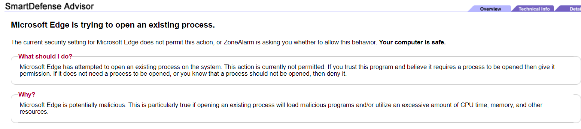

1. Next change the log type to “Firewall”

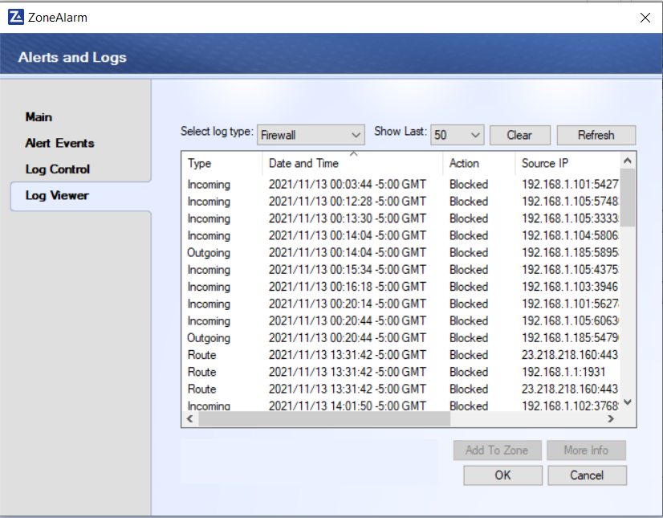

1. Click on one of the blocked actions and more information. SmartDefense Advisor will provide more information.

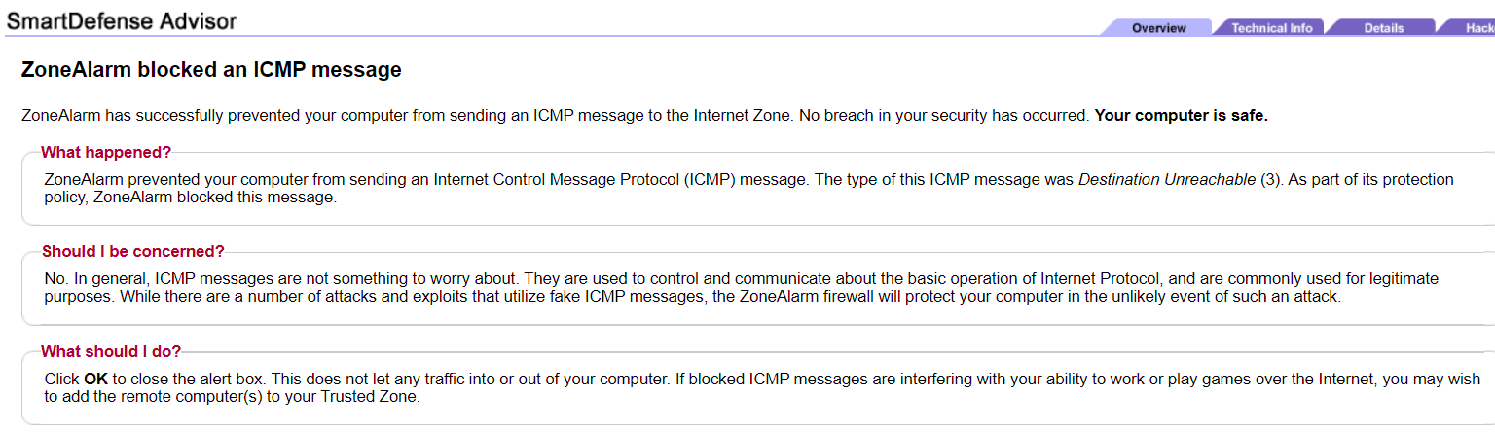

1. Next click on the Antivirus Tab. Our system is already detecting viruses and combating them. As part of our testing we will install a virus to our computer. Be very careful in the following steps

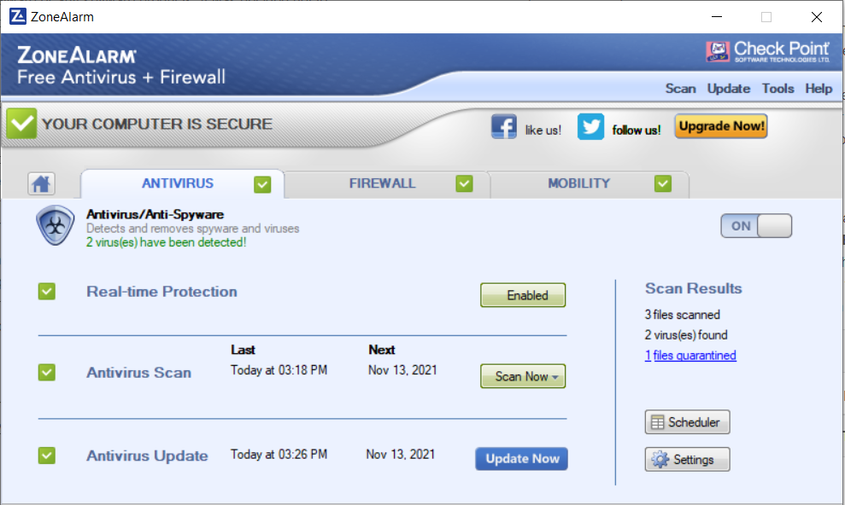

1. We will go to eicar.org/?page_id=3950 this is an organization that provides a virus to test our antivirus. We need to be careful since it is a live virus. Click on eicar.com where it says 68 Bytes this will download the virus to our computer.

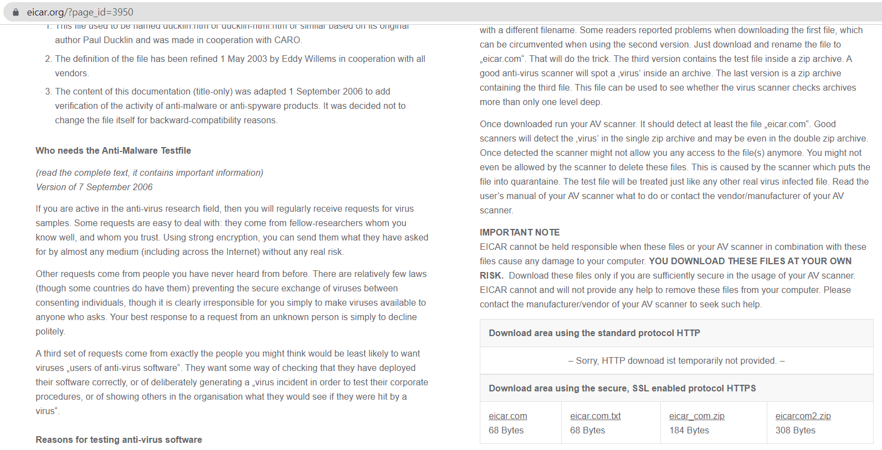

1. If you click on the file explorer and on download you will see eicar and that it is a MS-DOS Application. DO NOT CLICK OR RUN THE VIRUS

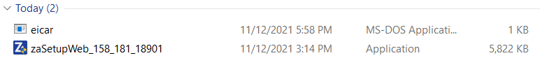

1. We will go back to ZoneAlarm and run a quick scan to see if it can spot the virus. User’s are the greatest security risks to our network and some users might accidentally download a virus to our system via an email (just like me!) so, we need to make sure that our system is performing daily scans to protect the network for downloaded viruses.

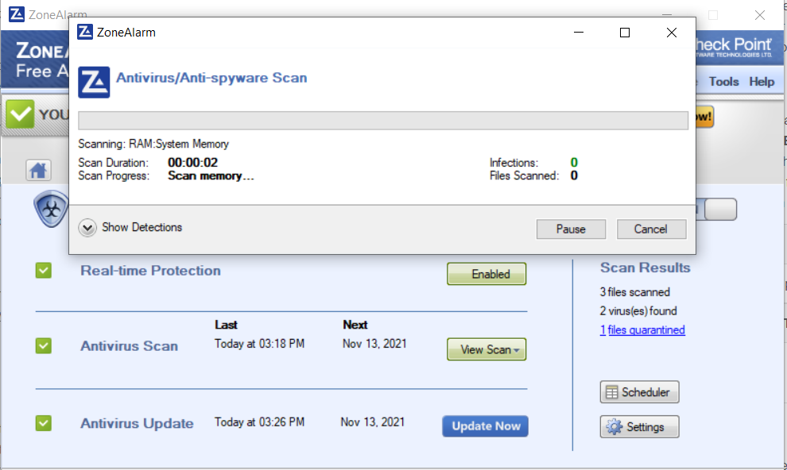

1. Great! The Scan worked, it identified the virus that was downloaded, labeled it’s risk category, logged it and treated it! That’s perfect. If we notice lots of infections we can investigate to see who in our network is downloading viruses through mistake or on purpose and then remediate their actions through either policy education or termination if necessary.

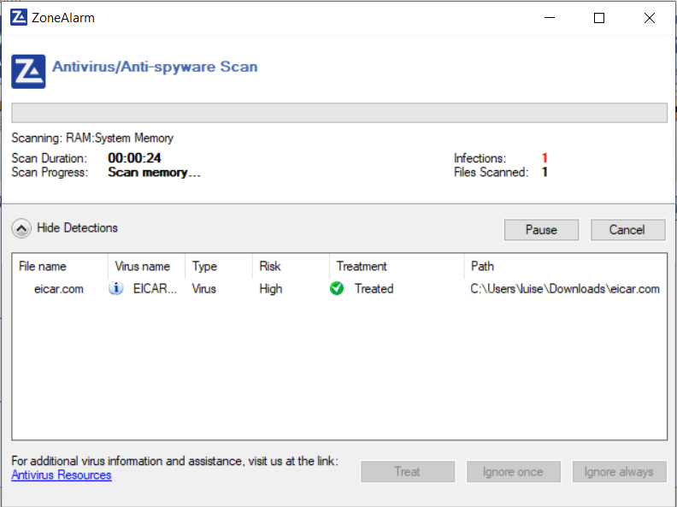

1. If we go to downloads we will see that the virus is no longer present. The Antivirus did a great job at finding and removing the threat!



1. If we go back to the Antivirus tab, we will see that it updated it’s screen to show the new results. Overall, on day one, three viruses were found. This would probably require further investigation, either a user is browsing unsafe sites or is doing this purposefully.

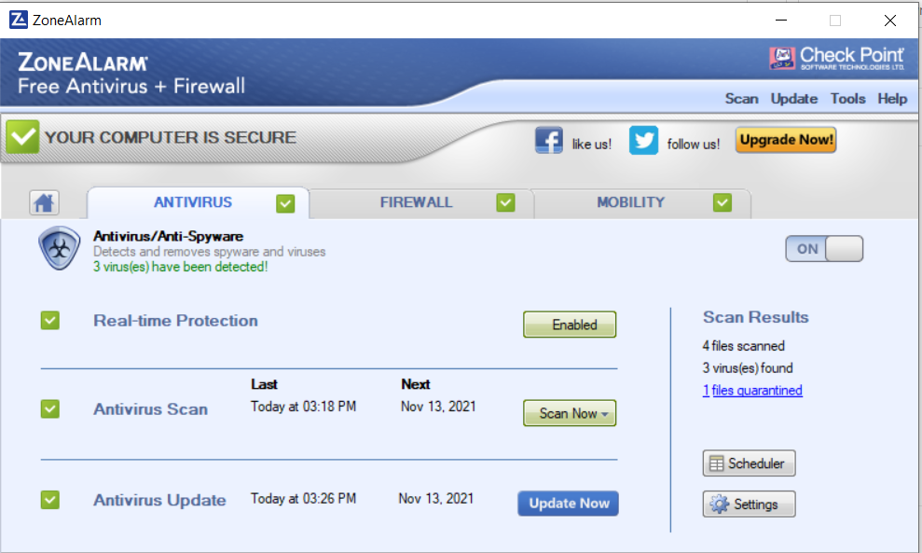

1. If we go to the Firewalls tab then to Log viewer and click on the Antivirus we will now see a log for the Antivirus. Turns out a user was installing viruses and canceling the scans! ZoneAlarm did a great job at alerting us and logging these events, this is a threat that needs to be remediated ASAP.

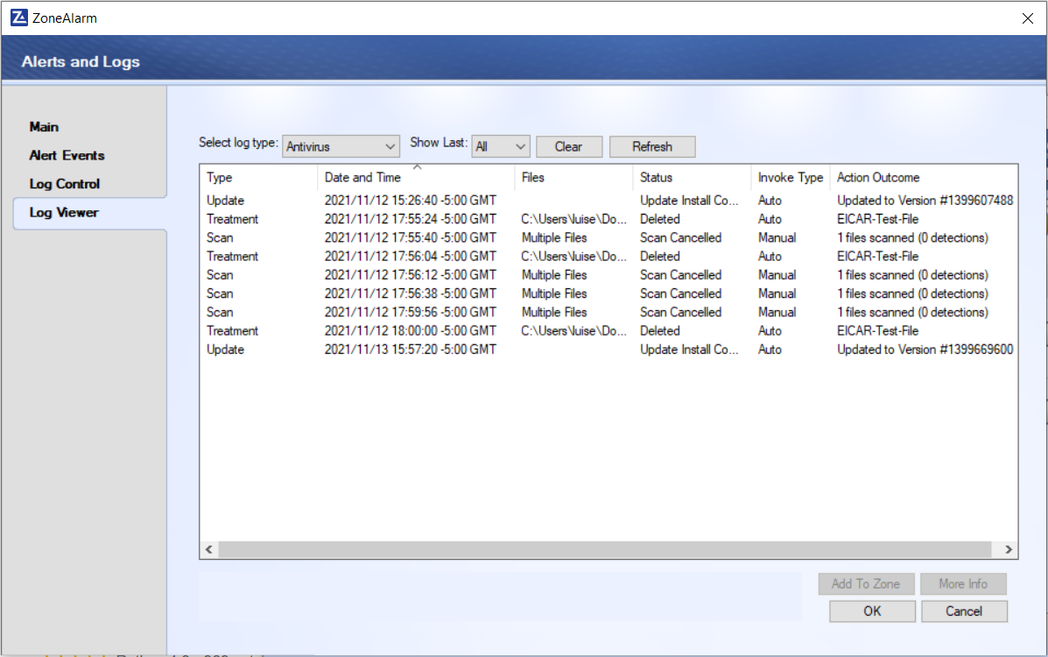

1. Now we will test the Firewalls. For this test, we will disconnect ProtonVPN. And go to hackerwath.org/probe/hitme.asp. Once ProtonVPN is disconnected we will click on hit me and wait a couple of minutes.

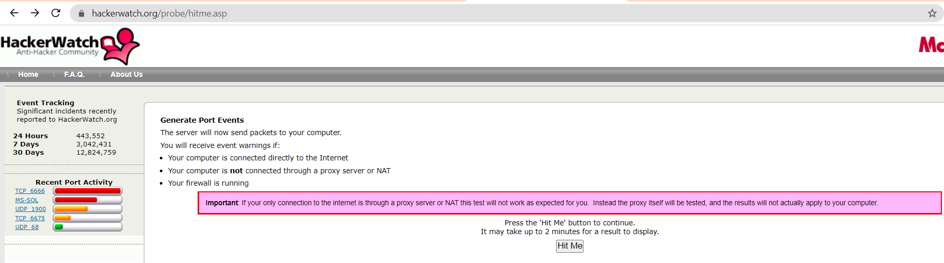

1. Our firewalls were configured successfully! Packets were sent but our firewalls were configured so well that their servers were unable to obtain a connection or any traffic from our computer. Our Firewalls, VPN and encryption methods are all working together without issues to protect our computer and network, just as intended.

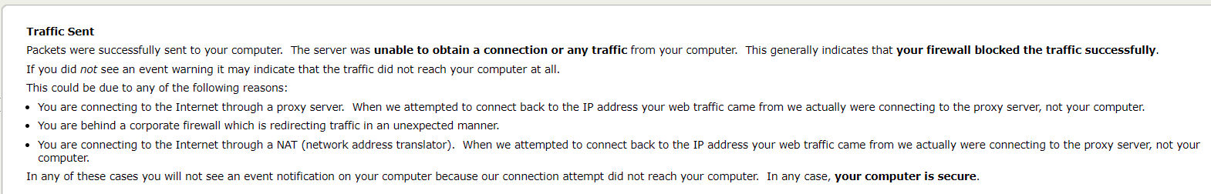

## Recommendations (Kari)

ZoneAlarm is a tool that works as a firewall and an antivirus. ZoneAlarm has a lot of features that are automated and require less user interaction to be effective. Our security team recommends that the user’s backup their log files from ZoneAlarm and reviews the online support to have a strong understanding of recognizing if an issue is occurring with the tool.

Backup logs: Logs are used to explore activity after an attack or unusual activity has been detected. It could be relevant to explore logs months even years earlier. To ensure that access to these logs are maintained there needs to be a backup schedule established to upload all log files to see secondary devices, either external drive or the cloud. Doing this will ensure that in the case of an event that prevents access to a device, the log files are still accessible.

Online Support: ZoneAlarm has online support available for all their tools, including the free versions. Below is the URL for the vendor's support page for the tool we installed. We recommend users review this information and keep the information close so that it can be readily used when needed. Additionally the vendor site has an online support chat available at this URL. Support URL: <https://support.zonealarm.com/hc/en-us/categories/360004940772-ZoneAlarm-Free-Antivirus>

## Alternatives (Marcos)

Bitdefender Total Security is a cross-platform antivirus security suite that offers more than antivirus protection. Bitdefender Total Security has an abundance of features focused on privacy optimization, and security. It has minimal performance impact on our systems while carrying out its operations. The platform is compatible with all major operating systems, such as Windows, macOS, Android, and iOS devices. It offers multi-device subscription plans; this means a single Bitdefender subscription can support 10 to 15 devices, giving our company excellent value for what we are purchasing. The Ashburn’s Frog Emporium has investigated this suite because of the need for an alternative firewall. Bitdefender Total Security includes a privacy firewall, which adds a robust layer of network protection that ensures no unauthorized incoming or outgoing internet traffic. The platform’s firewall ensures our company’s information stays safe from malicious actors. There are some cons to using Bitdefender Total security, for example, there is a limited VPN service of up to 200MB of bandwidth per device per day. Bitdefender is a widely used tool in the information technology field and performs many different functions. There are various subscription plans that can be implemented. The Total Security plan carries a free 30-day free trial, and the subscription period starts from 1 year to 3 years. Bitdefender Total Security goes for $49.99 and covers 10 devices for the first year. The first 2 years for 10 devices cost 169.99, whereas the 3-year plan costs 229.99 for 10 devices. The more devices we add to the subscription, the more Ashburn’s Frog Emporium would have to pay. In this case, we will continue to use and harden our built-in Windows Defender Firewall as well as the ZoneAlarm Firewall we have implemented. The Ashburn’s Frog Emporium would benefit from Bitdefender’s wide array of features that focus on privacy, optimization, and security. We would recommend implementing this platform Firewall function to further allow non-threatening traffic in and to keep dangerous traffic out.

# Conclusion (Kari)

Ashburn’s Frog Emporium hired our security team to design and implement an integrated defense in depth system to protect their sensitive data. We identified three tools to integrate into our defense strategy ZoneAlarm, ProtonVPN, and Windows Defender Firewall. ZoneAlarm is a powerful firewall and antivirus service that alerts the user if any malware or malicious traffic is detected. As an alternative firewall and antivirus software we recommend BitDefender Total Security. ProtonVPN is a free VPN service that is effective for encrypted communication out of the network. As an alternative tool we recommended NordVPN as a powerful paid VPN. Lastly, we hardened the built-in windows utility, Windows Defender Firewall. We configured some additional rules and enabled the logging functions. We recommended Avast Security Solution as an alternative firewall for our network. With these tools, Ashburn’s Frog Emporium can secure their inbound and outbound sensitive traffic as well as monitoring for and preventing malicious traffic onto the network.

# References

*Advanced Antivirus & Anti-Spyware Configuration*. (n.d.). ZoneAlarm.Com. https://www.zonealarm.com/learning-center/antivirus-and-anti-spyware/#scan-options

By Nicole Brooks (Writer)— Last Updated: 14 Jun’21 2021–06-14T13:59:27+00:00. (2021, June 14). *ZoneAlarm Antivirus Review - Updated 2021*. Cloudwards. https://www.cloudwards.net/zonealarm-antivirus-review/

C., Team, P., E., Team, P., P., C., Team, P., C., Team, P., E., G., Team, P., T., Team, P., V., Team, P., A., Team, P., MCCann, P., Team, P., . . . Team, P. (2021a, August 25). *ProtonVPN Android VPN App*. ProtonVPN Support. https://protonvpn.com/support/best-android-vpn-app/

D. (2021b, October 19). *Microsoft Defender for Endpoint on Linux*. Microsoft Docs. https://docs.microsoft.com/en-us/microsoft-365/security/defender-endpoint/microsoft-defender-endpoint-linux?view=o365-worldwide

D. (2021c, October 29). *Windows Defender Firewall with Advanced Security Administration with Windows PowerShell (Windows) - Windows security*. Microsoft Docs. https://docs.microsoft.com/en-us/windows/security/threat-protection/windows-firewall/windows-firewall-with-advanced-security-administration-with-windows-powershell

D. (2021d, October 29). *Windows Defender Firewall with Advanced Security (Windows) - Windows security*. Microsoft Docs. https://docs.microsoft.com/en-us/windows/security/threat-protection/windows-firewall/windows-firewall-with-advanced-security

D. (2021e, October 30). *Microsoft Defender for Endpoint on Mac*. Microsoft Docs. https://docs.microsoft.com/en-us/microsoft-365/security/defender-endpoint/microsoft-defender-endpoint-mac?view=o365-worldwide

D. (2021f, November 1). *Microsoft Defender for Endpoint on Android*. Microsoft Docs. https://docs.microsoft.com/en-us/microsoft-365/security/defender-endpoint/microsoft-defender-endpoint-android?view=o365-worldwide

F., Team, P., Roche, T., Team, P., N., Team, P., B., Team, P., S., Team, P., S., Team, P., Clayton, M., Team, P., V., Team, P., User, N., Team, P., M., . . . N. (2021g, August 25). *How to install and uninstall ProtonVPN on Windows*. ProtonVPN Support. https://protonvpn.com/support/install-windows-vpn/

Ilker, T., Crawford, D., K., Team, P., C., Team, P., B., Team, P., Key, K., Team, P., K., A., Team, P., A., A., Team, P., Janitor, C., Team, P., G., . . . Team, P. (2021, October 28). *ProtonVPN macOS Application*. ProtonVPN Support. https://protonvpn.com/support/protonvpn-mac-vpn-application/

*Installation*. (n.d.). ZoneAlarm.Com. https://www.zonealarm.com/learning-center/installation

M. (2021h, November 9). *Microsoft Defender for Endpoint on iOS*. Microsoft Docs. https://docs.microsoft.com/en-us/microsoft-365/security/defender-endpoint/microsoft-defender-endpoint-ios?view=o365-worldwide

Proton Technologies AG. (n.d.). *ProtonVPN - Pricing*. ProtonVPN. https://protonvpn.com/pricing

ProtonVPN. (2021a, August 25). *Setup Guide for new users*. ProtonVPN Support. https://protonvpn.com/support/protonvpn-setup-guide/

ProtonVPN. (2021b, October 28). *ProtonVPN iOS VPN App*. ProtonVPN Support. https://protonvpn.com/support/protonvpn-ios-vpn-app/

ProtonVPN. (2021c, November 11). *How to use ProtonVPN on Linux*. ProtonVPN Support. https://protonvpn.com/support/linux-vpn-setup/

*Security for small business*. (n.d.). ZoneAlarm. <https://www.zonealarm.com/business>

*Avast Premium Security | Online Security for Up to 10 Devices*. Avast Antivirus. https://www.avast.com/en-us/premium-security#pc

*Bitdefender Total Security - Anti Malware Software*. Bitdefender. https://www.bitdefender.com/solutions/total-security.html#choose-plan2

*Bitdefender vs. Zone Alarm: Which One is Better? [2021 Top Picks]*. SafetyDetectives. https://www.safetydetectives.com/comparison/bitdefender-vs-check-point/

Long, H., Byrd, B., & Garvie, I. (2021, November 4). *NordVPN vs ProtonVPN - One Clear Winner, One to Avoid*. RestorePrivacy. https://restoreprivacy.com/vpn/comparison/nordvpn-vs-protonvpn/

Nadel, B. (2021, July 8). *Bitdefender 2021 review*. Tom’s Guide. https://www.tomsguide.com/reviews/bitdefender